OFFICE PROCEDURES

TABLE OF CONTENTS

OPENING THE OFFICE
OPENING THE OFFICE CHECKLIST OP3
1) Turn on lights and prop open door OP4
2) Retrieve daily newspaper OP4
3) Turn on music and TV’S OP4
4) Turn on mail machine OP4
5) Clean kitchen OP4
6) Bake cookies, prepare coffee, and fill candy dish OP4
7) Keep reception area and conference rooms tidy throughout day OP4

CLOSING THE OFFICE
CLOSING THE OFFICE CHECKLIST OP5
1) Clean kitchen OP6
2) Turn off mail machine OP6
3) Turn off music and TV’S OP6
4) Clean kitchen OP6

MAINTAINING CLIENT INFORMATION AND FILES
MAINTAINING CLIENT INFORMATION AND FILES CHECKLIST OP7
1) Checking out client files OP8
2) Checking in client files OP9
3) Paper correspondence OP9
4) Electronic correspondence (e-mail) OP10
5) Literature requests OP10
6) Update missing or outdated information in contact management system OP12

Client Complaint
CLIENT COMPLAINT CHECKLIST OP13
1) Client notifies Advisor of complaint OP14
2) Forward complaint letter or notes to branch manager/OSJ and schedule on calendar to check status of issue OP14
3) Forward Complaint or Notes to compliance’s legal department OP14
4) Legal will forward a response to the advisor OP15
5) Legal sends response to client OP15
6) Advise the branch manager/OSJ of complaint resolution OP15

Compliance Approvals
COMPLIANCE APPROVALS CHECKLIST OP16
1) Prep materials for submission to compliance OP17
2) Complete broker dealer (B/D) advertising and sales literature form OP17
3) Record compliance approval tracking number OP19
4) Retain a copy of the mailing lists for all Client event invitations and/or mass mailings OP19
5) Compliance submissions for website changes and/or other submissions OP19

TIME MANAGEMENT
TIME MANAGEMENT CHECKLIST OP20
1) The 6 Most Important and Vital 1™ OP21
2) Team meetings OP22
3) Annual staff retreats OP23
4) Calendars OP25
5) Copytalk OP25

OPENING THE OFFICE CHECKLIST

This system will be used to open the office and is generally performed by the Director of First Impressions/Administrative assistant.

The following checklist and system is compiled assuming all practices are using some type of contact management software. For optimal effectiveness, we recommend you customize each checklist and system to reflect the actual steps that apply to your software/practice.

DATE: _______________

1) _____ Turn on lights and prop open door. ____ N/A
(Person Responsible)

2) _____ Retrieve daily newspaper. ____ N/A
(Person Responsible)

3) _____ Turn on music and TV’s. _____ N/A
(Person Responsible)

4) _____ Turn on mail machine. _____ N/A
(Person Responsible)

5) _____ Clean Kitchen. _____ N/A
(Person Responsible)

6) _____ Prepare coffee, Turn on Tea Pot and fill candy dish. _____ N/A
(Person Responsible)

7) _____ Keep reception area and conference rooms tidy throughout day. _____ N/A
(Person Responsible)

OPENING THE OFFICE

1) tURN ON LIGHTS and PROP OPEN DOOR

2) rETRIEVE DAILY NEWSPAPER

2.1) Remove the ad inserts.

3) TURN ON MUSIC and TV’S

3.1) Set CD Mode to repeat, random if possible.

4) TURN ON MAIL MACHINE

4.1) Remove key from hiding place.

5) CLEAN KITCEN

5.1) Empty dishwasher.

  - Load dishwasher with dirty dishes.

5.3) Check conference rooms for dirty dishes.

5.4) Keep items off the counter top.

6) PREPARE COFFEE, turn on tea pot and fill candy dish

7) KEEP RECEPTION AREA and CONFERENCE ROOMS TIDY THROUGHOUT DAY

7.1) Straighten papers.

  - Clean up spilled coffee supplies and cookie crumbs.

  - Load dirty cups in dishwasher.

CLOSING THE OFFICE CHECKLIST

This system will be used to close the office and is generally performed by the Director of First Impressions/administrative assistant.

The following checklist and system is compiled assuming all practices are using some type of contact management software. For optimal effectiveness, we recommend you customize each checklist and system to reflect the actual steps that apply to your software/practice.

DATE: ____________________

1) _____ Clean kitchen. ____ N/A
(Person Responsible)

2) _____ Turn off mail machine. ____ N/A
(Person Responsible)

3) _____ Turn off music and TV’s. _____ N/A
(Person Responsible)

4) _____ Turn off lights and lock door. _____ N/A
(Person Responsible)

CLOSING THE OFFICE

1) CLEAN KITCHEN

1.1) Load dishwasher and run to clean.

2) TURN OFF MAIL MACHINE

2.1) Replace key back in hiding place.

3) TURN OFF MUSIC and TV’S

4) TURN OFF LIGHTS and LOCK DOOR

MAINTAINING CLIENT INFORMATION AND FILES CHECKLIST

This system will be used to maintain update information on Clients, check Client files in and out, maintain correspondence files, and keep literature in stock as needed.

The following checklist and system is compiled assuming all practices are using some type of contact management software. For optimal effectiveness, we recommend you customize each checklist and system to reflect the actual steps that apply to your software/practice.

1) _____ Checking out Client files. ____ N/A
(Person Responsible)

2) _____ Checking in Client files. ____ N/A
(Person Responsible)

3) _____ Paper correspondence. _____ N/A
(Person Responsible)

4) _____ Electronic Correspondence (e-mail.) _____ N/A
(Person Responsible)

5) _____ Literature requests. _____ N/A
(Person Responsible)

6) _____ Update missing or outdated information in contact _____ N/A
management system. (Person Responsible)

MAINTAINING CLIENT INFORMATION AND FILES

1) CHECKING OUT CLIENT FILES

  - When taking a Client file from the filing cabinets, check-out the file by using an “Out” guide card.

  - “Out” guide cards should be located in a designated area.

  - Fill out the “Out” guide card by identifying your name under the column that states “Out To,” the name of the Client’s file you are removing from the filing cabinet under the column that states “File Number or Name Out” and the date you are removing the file from the filing cabinet under the column that states “Date.”

Checking Client Files In & Out

Note: To view the entire letters(s) or form(s), please refer to the Table of Contents in the Forms (FR) section of this Systems Manual.

  - Remove the file from the filing cabinet and place the “Out” guide card where the file was located.

  - If another co-worker is in need of the file that you have checked-out, they will be able to locate the file by going to the filing cabinet and looking at the “Out” guide card to see who has the file.

    - If you no longer need the file and decide to let the other co-worker take the file, go back to the filing cabinets and remove the “Out” guide card. A line should be drawn through your name and add a line with the individual who now has the file.

2) CHECKING IN CLIENT FILES

  - When returning a file to the filing cabinet, remove the “Out” guide card and place the file where the “Out” guide card was located.

  - On the “Out” guide card, put a line through the file name to confirm that you have checked-in the file.

2.3) Return the “Out” guide card to the top of the designated area for others to use.

3) PAPER CORRESPONDENCE

3.1) NASD defines correspondence as any written or electronic communications between a Prospect or Client and an Advisor.

3.2) No less frequently than weekly, you must submit to your Branch Manager/OSJ ALL INCOMING AND OUTGOING CORRESPONDENCE. Which includes:
- Handwritten birthday cards and notes
- Mail from Clients
- Mail sent to Clients
- Faxes from Clients
- Faxes sent to Clients

3.3) Daily incoming mail and faxes should be opened/sorted by Operations Associate.

3.4) Make 2 copies of all correspondence received for each Advisor and 3 copies of all correspondence for each Associate Wealth Advisor.

3.5) Branch Manager/OSJ reviews originals and maintains correspondence file for the Office.

3.6) Copy 1 – Client’s file.

3.7) Copy 2 – Advisor’s correspondence file.

3.8) Copy 3 – given to Advisor and/or Associate Wealth Advisor to review and act upon.

4) ELECTRONIC CORRESPONDENCE (E-MAIL)

4.1) NASD defines correspondence as any written or electronic communications between a Prospect or Client and an Advisor.

4.2) Immediately upon receipt of all e-mails, Branch Manager/OSJ should receive a forwarded copy of the e-mail.

4.3) Make 2 copies of all correspondence received for each Advisor and 3 copies of all correspondence received for each Associate Wealth Advisor.

  - Branch Manager/OSJ reviews e-mail, makes a copy and maintains correspondence file for the Office.

  - Copy 1 – Client’s file.

  - Copy 2 – Advisor’s correspondence file.

  - Copy 3 – given to Advisor and/or Associate Wealth Advisor to review.

5) lITERATURE REQUESTS

The Literature room will hold materials such as mutual fund prospectuses, annuity packets, life insurance packets, REIT packets, new account forms, beneficiary forms and any other materials used in your practice frequently.

To make the literature room easy to maintain, the Team Leader must check it at least every week to make sure that reorder cards have been turned in from the supply boxes needing replacement materials.
  - Literature room reorder form.

    - Reorder forms are printed on pink paper or other bright colors to allow for easy awareness once materials have been depleted and need to be reordered.

    - Each separate item in the Literature room will have a pink reorder form placed in the bottom ¼ of the stack of items (eg. REIT packets, mutual fund prospectus.)

    - Front of the form completed with an example in italics:

FUND FAMILY: Kemper

FUND NAME: Emerging Growth

PHONE: 1-800-000-0000

    - Back of the form completed with an example in italics:

DATE ORDERED QTY SHIPPING INSTRUCTIONS DATE RECD
10-28-2004 10 overnight 10-29-2004
03-15-2005 10 03-19-2005

Note: To view the entire letters(s) or form(s), please refer to the Table of Contents in the Forms (FR) section of this Systems Manual.

  - On a daily basis, literature should be ordered for the reorder cards received. Usually the reorder can be accomplished by calling the number on the front of the reorder card. Determine how many should be ordered based upon the number ordered last time and how quickly reorder was needed which is shown on the back of the reorder card.

  - Broker Dealer (B/D) forms such as new account forms may be accessed on your B/D’s website.

  - Forms will take approximately 3 -5 business days unless order was expedited.

  - Update the reorder card and place in the bottom ¼ of the stack of items in the literature room. Place the newer items on the bottom of the stack.

  - Throw away prospectuses that are more than one year old.

  - Make new reorder cards if any information such as fund name or the fund phone number has changed.

6) uPDATE MISSING OR OUTDATED INFORMATION IN CONTACT MANAGEMENT SYSTEM

For your contact management system to be used effectively, it is important to populate all fields as described in the User Manual. Some of those fields to consider are:
- Dear or salutation
- Gender
- Birthdates
- Social Security numbers
- Address
- Phone numbers
- Rating
- Representative number
- Update frequency

Breaking Away™: This involves printing the “Clients Missing Important Info” Crystal Report.

  - Under the PATRIOT Act, it is necessary to have current identification information on all Clients. ID’s past their expiration date are not considered current. Information that should be maintained within your contact management system is:
- ID type (eg. passport, driver’s license)
- Place ID Type was issued from
- ID number (if applicable)
- ID expiration

Clients with expired ID’s should be updated quarterly.

Breaking Away™: This involves printing the “Client ID's Due to Expire” Crystal Report.

CLIENT COMPLAINT CHECKLIST

This system will be used when a complaint is received from a Client either in writing, in-person, e-mail or by phone. Once a complaint is received, it is best to allow your Branch Manager/OSJ or the Legal Department handle all Client inquiries until the issue is resolved.

The following checklist and system is compiled assuming all practices are using some type of contact management software. For optimal effectiveness, we recommend you customize each checklist and system to reflect the actual steps that apply to your software/practice.

CLIENTNAME: ________________________________________ DATE STARTED: ___________

NATURE OF COMPLAINT: ________________________________________________________________________________________________________________________________________________________________________________________________________________________________________________________________________________________________________________________________________________

1) _____ Client notifies Advisor of complaint. ____ N/A
(Person Responsible)

2) _____ Forward complaint letter or notes to Branch Manager/OSJ and ____ N/A
schedule on calendar to check status of issue. (Person Responsible)

3) _____ Forward complaint or notes to Compliance’s Legal Department. _____ N/A
(Person Responsible)

4) _____ Legal will forward a response to the Advisor. _____ N/A
(Person Responsible)

5) _____ Legal sends response to Client. _____ N/A
(Person Responsible)

6) _____ Advise the Branch Manager/OSJ of complaint resolution. _____ N/A
(Person Responsible)

CLIENT COMPLAINT

1) Client notifies Advisor of complaint

1.1) Client calls, stops by office, e-mails or mails letter with complaint.

2) Forward Complaint Letter or Notes to Branch Manager/OSJ and schedule on calendar to check status of issue

  - Contact with the Client should be through either your Branch Manager/OSJ or your Legal Department until the issue has been resolved.

  - Schedule an activity on your calendar to check status of complaint.

Breaking Away™: This involves scheduling a Next Action on the calendar.

    - Track the following information:
  - Date complaint received from Client
  - Date complaint information given to Branch Manager/OSJ
  - Date complaint information faxed to legal
  - Date letter of resolution received from legal
  - Date letter of resolution submitted to legal with suggested changes
  - Date letter of resolution sent to Client
  - Net worth
    - Use an Activity Code of CM- from the lookup list to indicate activity is a Complaint.

2.3) It is advisable to check on the resolution of this issue no less than on a weekly basis. Notes of the progress should be maintained within the calendar record.

Breaking Away™: This involves editing a Next Action on the calendar.

3) Forward Complaint or Notes to Compliance’s Legal Department

3.1) Within 1 day, notification should have been sent to the Legal department along with any notes and supporting documents that you may wish to provide to the Legal department to support your side of the complaint.

3.2) The Legal department may request additional information.

4) Legal Will Forward a Response to the Advisor

4.1) After review of the complaint from the Client, the Legal department, will compose a resolution letter to the Client.

4.2) Prior to mailing the letter to the Client, the Advisor will be allowed to make suggestions for changes.

5) Legal Sends Response to Client

  - Once final agreement has been reached by the Advisor and Legal, then the resolution letter will be sent to the Client, with a copy to the Branch Manager/OSJ and a copy for the Client’s file.

  - Complete the final notes on your calendar record.

6) Advise the Branch Manager/OSJ of Complaint Resolution

6.1) Let the Branch Manager/OSJ know what resolution is being proposed to the Client.

6.2) The next step in the process is the Client’s on whether to accept the proposed resolution or pursue further legal action.

Compliance Approvals Checklist

This system will be used to submit any advertising, letterhead, website changes, seminars, forms etc., for compliance for approval. Any advertisement (e.g., print, radio or TV), communications such as e-mails, or form letters that are being sent to more than 1 Client or Prospect must be submitted for approval.

The following checklist and system is compiled assuming all practices are using some type of contact management software. For optimal effectiveness, we recommend you customize each checklist and system to reflect the actual steps that apply to your software/practice.

1) _____ Prep materials for submission to compliance. ____ N/A
(Person Responsible)

2) _____ Complete Broker Dealer (B/D) advertising and sales literature ____ N/A
form. (Person Responsible)

3) _____ Record compliance approval tracking number. ____ N/A
(Person Responsible)

4) _____ Retain a copy of the mailing lists for all Client event invitations ____ N/A
and/or mass mailings. (Person Responsible)

5) _____ Compliance submissions for website changes and/or other ____ N/A
submissions. (Person Responsible)

Compliance Approvals

1) Prep materials for submission to compliance

1.1) On all submissions, include the Broker Dealer (B/D) disclosure information.

Disclosure for Gold Coast Securities offices:

Securities offered through Gold Coast Securities, Inc. Member FINRA/SIPC and an Investment Advisor.

Note: “Member FINRA/SIPC” must ALWAYS be typed 2 points smaller

1.2) Include any special disclosure notations for Client events required by your B/D.

If held in a bank:

Not FDIC Insured * No Bank Guarantee * May Lose Value
Not a Deposit * Not Insured By Any Federal Government Agency

[Insert Name of Bank] is not affiliated with Gold Coast Securities, Inc.

If referencing real estate investments:

Investments in real estate and limited partnerships have various risks including possible lack of liquidity and may not be suitable for all investors. Additionally, investments in real estate will fluctuate with the value of the underlying properties, and your investment may be worth less than the original purchase price when redeemed.

2) Complete Broker Dealer (B/D) Advertising and Sales literature form

  - For each item submitted, you must first complete you B/D’s advertising and marketing submission form.

For Gold Coast Securities Advisors ONLY:

    - Locate Advertising and Sales Literature form.

2.2) Once completed, fax the form along with the piece being submitted to Compliance for approval. Provided your Advisor meets these criteria, be sure to place a “Chairman’s Processing” sticker at the top of the page prior to faxing.

Compliance will return the submission notating one of the following options:
A – Approved
B – Approved with changes
C – Disapproved/revision necessary
D – OK, once registered
E – NASD filing is required

Before being able to use the submission, you must receive an A, B or D from compliance. All other notations must be modified and resubmitted before receiving approval to use.

2.3) Once you have received the form back indicating compliance’s approval, staple the form to the approved item and file in the compliance binder.

3) Record compliance approval tracking number

3.1) Keep a spreadsheet in a compliance binder that records the title for the item approved, the approval number, the date approved, and the date the approval will expire.

4) Retain a copy of the mailing lists for all Client event invitations and/or mass mailings

4.1) Save a paper copy of the mailing list and attach it to the approval form for each approved invitation, mass mailing, or item sent.

5) Compliance submissions for website changes and/or other submissions

  - Changes must be approved by compliance prior to the changes going “live.”

  - For specific instructions on how to submit items to compliance for approval, please see Sections 2.1 – 2.3.

  - Once you have received the form back indicating compliance’s approval, staple the form to the approved change and record on the compliance binder spreadsheet.

TIME MANAGEMENT CHECKLIST

These systems will help you organize your time more efficiently.

The following checklist and system is compiled assuming all practices are using some type of contact management software. For optimal effectiveness, we recommend you customize each checklist and system to reflect the actual steps that apply to your software/practice.

CLIENTNAME: _____________________________________ DATE STARTED: ___________

1) _____ The 6 Most Important with Vital 1™. ____ N/A
(Person Responsible)

2) _____ Team Meetings. ____ N/A
(Person Responsible)

3) _____ Annual Staff Retreats. _____ N/A
(Person Responsible)

4) _____ Calendars. _____ N/A
(Person Responsible)

5) _____ Copytalk. _____ N/A
(Person Responsible)

This checklist can be printed from the InfoCenter | Systems Manual Docs | Office Procedures | “Time Management Checklist”.

TIME MANAGEMENT

1) THE 6 MOST IMPORTANT AND VITAL 1™

  - Prior to leaving work each day, make a list of The 6 Most Important Things you need to do the next business day. The list must be in priority order and must be placed on top of your desk at the end of each day.

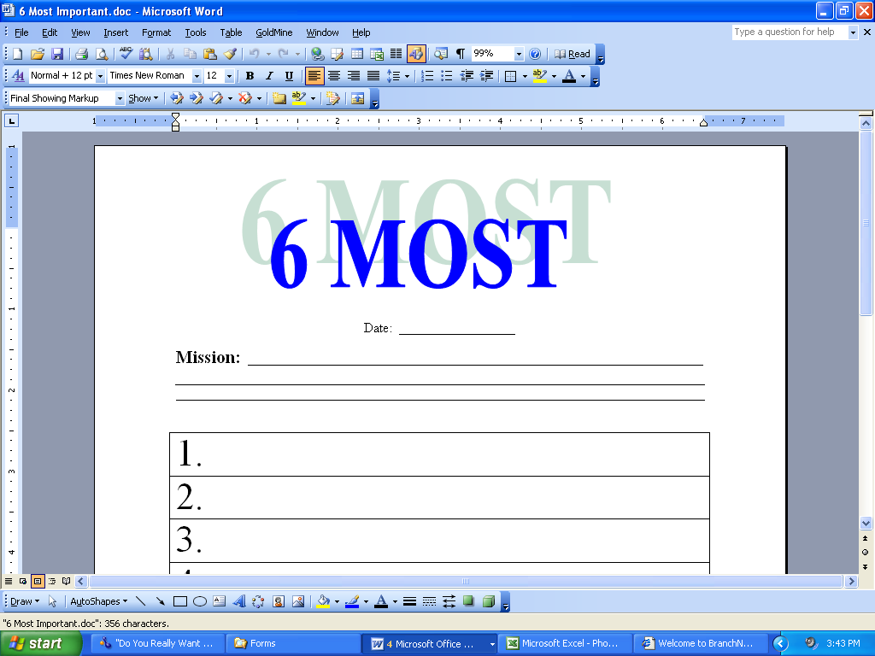

Note: To view the entire letters(s) or form(s), please refer to the Table of Contents in the Forms (FR) section of this Systems Manual.

This involves printing a form from the InfoCenter | Systems Manual Docs | Office Procedures | “6 Most Important”.

  - Advantages:

    - If ill, another team member can quickly identify your priority items that must be addressed while you are gone.

    - The list provides a starting point for each day. Less time is wasted trying to decide what work to do first. Additionally, once you have the list, you will spend less time worrying about work-related activities during the evenings or weekends.

    - Returning to your list after interruptions alleviates retracing your steps.

1.2.4) After 30 days, this task will have become a habit.

1.3) The 6 Most daily forms should be maintained in a file for 6 months.

2) tEAM MEETINGS

  - Team meetings are essential for effective team communications. A 30-60 minute weekly meeting or a 10-15 minute daily meeting will keep everyone abreast of what is happening with other team members.

Note: The purpose of the daily team meetings is to eliminate multiple interruptions through the workday for items such as signatures on paperwork and questions. Emergencies are the exception to this rule.

Note: For larger offices, you may wish to consider having a Team Leader meeting daily and All Team meetings either weekly or on an as needed basis.

  - Compile an agenda prior to the weekly meetings.

    - Document should be in a location where everyone can make additions to the document.

    - Each team member should add items to the agenda for discussion during the meeting. The team member should include their initials after their topic name.

    - Team Leader or Advisor will review agenda prior to meeting to verify the topic(s) are relevant to the group.

    - Team member should be notified if topic won’t be covered in the meeting. Item may be discussed either on a one-on-one basis or included in the next annual retreat.

    - Agenda is printed for each team member.

  - Meeting notes should be taken at all meetings and submitted to the entire group for review of items covered. Person taking notes should bring the previous week’s notes to verify that open items from last meeting were completed or should be carried over to next week.

  - Examples of items to cover in a Team Meeting include but are not limited to the following list:

- Return of signed paperwork and letters
- Return materials to be filed
- Assign specific tasks or projects
- Trade orders
- Review pending business
- Review weekly calendar and upcoming events
- Complete appointment checklists
- Talk about problem areas
- Review any new Clients
- Get answers for Client questions
- Brainstorm ideas for Client events, more efficient use of technology, etc.
- Review any new or modified systems

3) aNNUAL Staff rETREATS

3.1) Long-range planning and evaluation meetings are also important. Annual meetings are ideally held away from the office and last ½ to 1 full day.

3.2) Compile the agenda throughout the year.

3.2.1) Document should be in a location where everyone can make additions to the document.

    - Each team member should add items to the agenda for discussion during the meeting. The team member should include their initials after their topic name.

    - Team Leader or Advisor will review agenda prior to meeting to verify the topic(s) are relevant to the group and not for team meeting discussion.

    - Team member should be notified if topic won’t be covered in the annual retreat. Item may be discussed either on a one-on-one basis or included in the next team meeting.

    - When writing the final agenda, the 1st topic should be a communication starter.

    - When writing the final agenda, the last topic should be final thoughts.

    - Agenda is printed for each team member.

Annual Staff Retreat Agenda

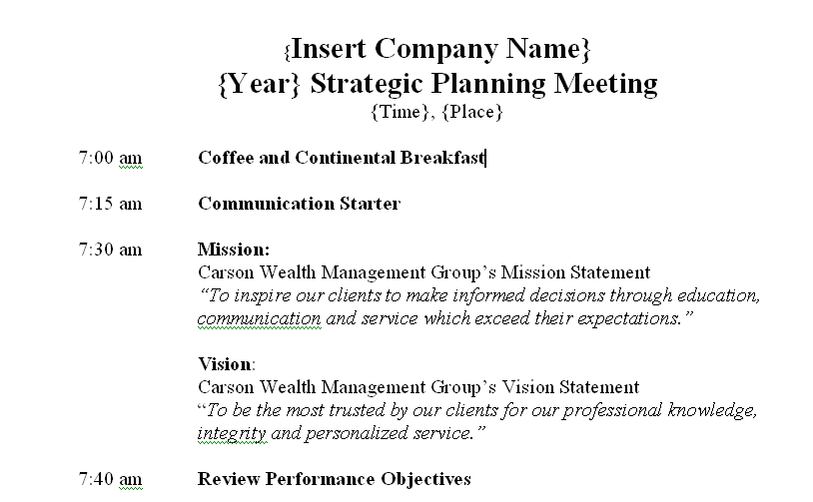

Note: To view the entire letters(s) or form(s), please refer to the Table of Contents in the Forms (FR) section of this Systems Manual.

Breaking Away™: You can view this form from the InfoCenter | Systems Manual Docs | Office Procedures | “Annual Staff Retreat Agenda”.

3.3) Meeting notes should be taken at all meetings and submitted to the entire group for review of items covered.

  - Examples of areas to cover in Annual Staff Retreats include but are not limited to the following list:
- Assess progress toward team and individual goals
- Plan and schedule future events
- Review the Mission & Vision statements
- Make changes to annual survey
- Determine gifts for male and female A+, A, B & C Clients for next year
- Focus on systems development and training
- Discuss the impact of any changes in the industry

4) cALENDARS

  - Each team member should maintain a calendar within contact management system which is preferably obtainable by all.

  - Monthly Calendar - Each month, the Director of First Impressions prepares a calendar for all of the team members to keep at their desks. It includes the following:

- Team members birthdays and anniversaries
- Team members on vacation or attending workshops
- Client events
- Team lunches or retreats
- Office functions
- Holidays

4.3) Yearly Calendar – Use a large, 12-month wall calendar to plan out the year. Locate in an area that is easily viewed by everyone in the office. Be sure to use dry-erase markers because changes do happen. The following information is included:

- Client events
- Office functions
- Workshops/meetings that will be attended by Advisor(s) and/or Team
- Retreat dates
- Team member birthdays

5) cOPYTALK

Copytalk is a company we use to quickly transcribe notes, letters, minutes, etc. at a very affordable cost. For sales support, they may be contacted at 941-894-0010 or on the internet at www.copytalk.com. A discounted rate has been arranged and may be obtained by accessing www.joinpeak.com. On the member’s only website, the link is found under Tools of Success. For non-members, the link is found under PEAK Products and Resources.

  - The Advisor dictates a letter reviewing the items discussed during the meeting with the Client to Copytalk. The Advisor needs to be sure to indicate to Copytalk the name of the staff person the completed transcription e-mail should be sent to.

  - The Advisor will want to specifically mention that the investment objective was discussed, what the objective is and whether a change is being made and to what objective.

  - Copytalk transcribes the content of the dictation and forwards an e-mail back to the Advisor and the designated staff member.

5.4) E-mail received from Copytalk and a letter is composed.

5.5) Schedule an activity on your calendar to track the mailing of the letter.

Breaking Away™: This involves scheduling a Next Action on the calendar.

    - Track the following information:
  - Meeting Date
  - Letter Dictated
  - Letter Drafted
  - Letter to Team Leader for Review
  - Letter to Advisor for Review
  - Final Copy Sent to Client

    - Use an Activity Code of UPD from the lookup list to indicate activity is a Periodic Review/Update (or use the appropriate Activity Code to correspond with the activity you are creating.)

5.6) It is advisable to check on the mailing of the letter daily. Notes of the progress should be maintained within the calendar record.

Breaking Away™: This involves editing a scheduled Next Action on the calendar.

  - Once the e-mail is received with the dictation, copy and paste the text in the dictated e-mail received from Copytalk into the desired Template in your contact management system.
Appointment Follow-up Letter

Note: To view the entire letters(s) or form(s), please refer to the Table of Contents in the Forms (FR) section of this Systems Manual.

This involves merging the “Appointment Follow-Up Letter” letter located in the Document Management Center | Document Templates | Global Templates.

5.8) Print and review the letter for errors.

5.9) Make corrections to the letter as needed.

This involves editing a saved letter located in the Links Tab.

  - Print on letterhead and have Advisor sign.

This involves editing a saved letter located in the Links Tab.

  - Make copies as per your compliance and retention systems.

  - Address envelope, print label or place letter in window envelope.

This involves printing a label/envelope using a GoldMine Report.

5.13) Any staff members mentioned in the body of the letter should also be carbon copied at the bottom of the letter. A copy of the letter or an e-mail containing the letter is to be sent to that referenced individual to follow up on the outstanding items that pertain to their responsibilities.

5.14) Complete the final notes on your calendar record.

This involves completing a scheduled Next Action on the calendar.

    - Use a Result Code of COM from the lookup list to indicate activity is Complete.

