CLIENT APPRECIATION

TABLE OF CONTENTS

LOVE-AFFAIR MARKETING™
LOVE-AFFAIR MARKETING™ CHECKLIST CA3
1) Mail extensive personal questionnaire to clients CA4
2) What clients can expect CA5

CLIENT CONTACT
CLIENT CONTACT CHECKLIST CA7
1) Birthday CA8
2) Client anniversary with practice CA10
3) Wedding Anniversary CA12
4) Birth or adoption CA14
5) Illness or death CA14 6) Random Acts of Kindness CA15
7) Audio presentations CA16
8) Gift ideas CA17
9) Newsletter CA17
10) Weekly market commentary CA18
11)Special mailings CA21
12) Monthly/Quarterly Calls CA22

Seeking Referral
SEEKING REFERRAL CHECKLSIT CA24
1) Filter A+ & A clients CA25
2) Send seeking referral letter CA25

GENERAL EVENTS
GENERAL EVENTS CHECKLIST CA27
1) Event ideas CA28
2) Client event checklist CA28
3) Invitation checklist CA29
4) Client event budget CA29
5) Food and drink suggestions CA30
6) Reservation line CA30
7) Entering RSVP information in contact management system CA31
8) Event sign-in & evaluation CA32
9) Event nametags CA35
10) Prospects attending event CA37
11) Visualize the event CA38
12) Compliance requirements for events CA39
13) Event agenda CA40

MISC. EVENTS
MISC. EVENTS CHECKLIST CA41
Office Wine Event
1) Invitations CA42
2) Place cards CA42
3) Wine menu CA42
4) Wine for the event CA43
5) Food for the event CA43
6) Table set-up CA45
7) Dinner bill CA45
8) Prospect packet CA45
9) Event coordinator’s role during event CA46
Dinner and Presentation Events
10) Dinner CA49
11) Presentation CA51
Annual Holiday Brunch Event
12) Facility arrangements/set-up CA53
13) Entertainment CA53
14) Table set-up/centerpieces CA54
Friday Afternoon Club Events
15) Staff and/or clients CA55
16) Food and beverages CA55
17) Conference room set-up CA55

LOVE-AFFAIR MARKETING™ CHECKLIST

This system will be used to collect and deliver exceptional Client service and appreciation to Clients.

1) _____ Mail Extensive Personal Questionnaire to Clients. ____ N/A
(Person Responsible)

2) _____ What Clients can expect. ____ N/A
(Person Responsible)

LOVE-AFFAIR MARKETING™

1) mAIL EXTENSIVE PERSONAL QUESTIONNAIRE to Clients

  - Identify Clients you wish to send the questionnaire to.

Note: Carson Wealth only collects this information from A+ and A Clients.

  - Make copies of the questionnaire for the Clients you wish to receive it. This document is not personalized and there is no cover letter to accompany the questionnaire.

Extensive Personal Questionnaire

Note: To view the entire letters(s) or form(s), please refer to the Table of Contents in the Forms (FR) section of this Systems Manual.

  - Address envelope, print label or place letter in window envelope.

2) wHAT CLIENTS CAN EXPECT

  - The following is a list of gifts and correspondence sent to different Client ratings (A+, A, B, etc.)

Client Gifts Breakdown

Event |  | A+ | A | B | C | D | Prospect/Drip
Newsletter |  | X | X | X | X | X
Event Invitations |  | X | X | X | X | X | X
Christmas Letters |  | X | X | X | X | X
Christmas Card with picture |  | X | X | X
Calendar |  | X | X | X
Valentines  Chocolate |  | X
Monthly Calls |  | X
Quarterly Calls |  |  | X | X
Birthday Gifts |  | X  25 | X  20 | X  15 | X  12
Birthday Calls |  | X | X | X | X
Client Anniversary Gifts  5th, 10th, 15th, 20th , etc. |  | X  25 | X  20 | X  15 | X  12
Client Anniversary Calls |  | X | X | X | X
Wedding Anniversary Gifts  5th, 10th, 15th, 20th , etc. |  | X  25 | X  20 | X  15 | X  12
Wedding Anniversary Calls |  | X | X | X
Audios of Client events |  | X | X (not local)
E-Mails |  | X | X | X | X | X | X
Other occasions (new baby, illness, death) |  | X  25 | X  20 | X  15 | X  12
Random Acts of Kindness |  | X  25 | X  20 | X  15 | X  12

CLIENT CONTACT CHECKLIST

This system will allow you to systematically remain in contact with your Clients through various means.

1) _____ Birthday. ____ N/A
(Person Responsible)

2) _____ Client anniversary with practice. ____ N/A
(Person Responsible)

3) _____ Wedding anniversary. ____ N/A
(Person Responsible)

4) _____ Birth or adoption. _____ N/A
(Person Responsible)

5) _____ Illness or death. _____ N/A
(Person Responsible)

6) _____ Random Acts of Kindness. ____ N/A
(Person Responsible)

7) _____ Audio presentations. _____ N/A
(Person Responsible)

8) _____ Gift ideas. _____ N/A
(Person Responsible)

9) _____ Newsletter. _____ N/A
(Person Responsible)

10) _____ Weekly market commentary. _____ N/A
(Person Responsible)

11) _____ Special mailings. _____ N/A
(Person Responsible)

12) _____ Monthly/Quarterly calls. _____ N/A
(Person Responsible)

CLIENT CONTACT CHECKLIST

1) Birthday

NOTE: If you have a contact management system that uses Automated Processes, they can be used to schedule reminders to contact your clients for their birthdays. Automated processes are available to clone as part of Breaking Away™.

1.1) On the 20th of each month, print a list of birthdates in the following month.

  - Review the list, add nicknames if needed, review if Client is at an alternate address (summer location vs. winter location), and fax the list to selected Vendor.

Note: Our Vendor suggestion is Category One located in Omaha, Nebraska but available to ship nationwide. Kelly Kleen with Category One can be reached at 402-390-9684 for details.

Note: For gift ideas, see the Gift Ideas section later in this system.

1.3) Make note in contact management system that gift was requested from Vendor.
1.4) If activity appears on calendar, send Client a birthday card.
1.5) If activity appears on calendar, send birthday e-mail.
1.6) A call will also be placed by the Advisor on the day of the Client’s birthday (the call is made even if it falls on a weekend). Instead of looking at their calendars, some advisors prefer to have a paper list of who to call.
1.7) Once the Advisor has placed the call to the Client, the Call should be completed on the calendar.

2) Client Anniversary with practice

NOTE: If you have a contact management system that uses Automated Processes, they can be used to schedule reminders to contact your clients for their anniversary with your firm. Automated processes are available to clone as part of Breaking Away™.

  - On the 20th of each month, print a list of Client anniversaries (anniversary of date became Client with practice) in the following month.

  - Review the list, add nicknames if needed, review if Client is at an alternate address (summer location vs. winter location), fax the list to selected Vendor.

Note: The Vendor should only receive a list of Clients celebrating a major anniversary with the practice (eg. 5, 10, 15, 20 and every 5 years thereafter.)

Note: Our Vendor suggestion is Category One located in Omaha, Nebraska but available to ship nationwide. Kelly Kleen with Category One can be reached at 402-390-9684 for details.

Note: For gift ideas, see the Gift Ideas section later in this system.

2.3) Make note in contact management system that gift was requested from Vendor.
2.4) If activity appears on calendar, send Client a card.
2.5) If activity appears on calendar, send an e-mail.

2.6) A call will also be placed by the Advisor on the day of the Client’s anniversary (the call is made even if it falls on a weekend). Instead of looking at their calendars, some advisors prefer to have a paper list of who to call.
2.7) Once the Advisor has placed the call to the Client, the Call should be completed on the calendar.

3) Wedding Anniversary

NOTE: If you have a contact management system that uses Automated Processes, they can be used to schedule reminders to contact your clients for their wedding anniversaries. Automated processes are available to clone as part of Breaking Away™.

  - On the 20th of each month, print a list of wedding anniversaries in the following month.

  - Review the list, add nicknames if needed, review if Client is at an alternate address (summer location vs. winter location), fax the list to selected Vendor.

Note: The Vendor should only receive a list of Clients celebrating a major wedding anniversary (eg. 5, 10, 15, 20 and every 5 years thereafter.)

Note: Our Vendor suggestion is Category One located in Omaha, Nebraska but available to ship nationwide. Kelly Kleen with Category One can be reached at 402-390-9684 for details.

Note: For gift ideas, see the Gift Ideas section later in this system.

  - Make note in contact management system that gift was requested from Vendor.

3.4) If activity appears on calendar, send Client a card.
3.5) If activity appears on calendar, send an e-mail.
3.6) A call will also be placed by the Advisor on the day of the wedding anniversary (the call is made even if it falls on a weekend). Instead of looking at their calendars, some advisors prefer to have a paper list of who to call.
3.7) Once the Advisor has placed the call to the Client, the Call should be completed on the calendar.

4) Birth or Adoption

  - When notification is received of a birth or adoption of a Client’s new baby or grandbaby, a gift should be sent to the Client.

    - Baby – Local Clients receive flowers and outside of local area Clients receive a gift basket.

    - Grandbaby – same for new baby unless the parent and grandparents are both Clients. In this case, the gift is sent only to the parents.

4.2) Make note in contact management system that gift was requested from Vendor.

5) Illness or death

  - When notification is received of an illness, upcoming surgery or death, send flowers according to the What to Expect Table in the Love-Affair Marketing Section. Make a note in History of the gift being sent and the condition of the Client.

5.2) Make note in contact management system if gift was sent.

5.3) For illnesses and surgeries, a follow-up call should be scheduled on a team member’s calendar to call Client in two-weeks.

5.4) For deaths, reference the Death Claims system in the Customer Service Section of this Systems Manual.

6) Random Acts of Kindness

6.1) Random Acts of Kindness occasions to be on the lookout for: (Think unique and unexpected)

New home
Retirement
Further education
Death of pet
Kids move out
New pool
Remodeling complete
New dream car
Community award
Mentioned in newspaper

  - Information should be collected from Clients in appointments, phone calls and Client events and recorded in contact management system.

  - Once a Random Act of Kindness has been given to a Client, it should be recorded in the Details tab.

  - Determine number of Random Acts of Kindness given within the quarter.

7) Audio presentations

7.1) Many events will become favorites of your Clients and for reasons, such as moving out-of-state or other commitments, your Clients may not be able to attend an event. For this reason, we send all A+ and non-local A Clients a CD with the audio of the events.

7.2) On the CD, we include an introduction such as the following:

One of the many benefits of being a “Your company name here” Client is the opportunity to meet and speak with industry specialists and professionals such as Dr. Bob Froehlich who is a Chief Investment Strategist with Scudder Investments and is considered an expert in his field.

I would like to take this opportunity to encourage you to share this recording with a friend, family member or associate whom you feel may benefit from his professional insight and expertise. After listening to Dr. Bob’s presentation I would be delighted to meet with this individual personally and answer any immediate questions that they may have. After all, that is why we are here.

On the CD, we also include a closing such as the following:

I hope you enjoyed listening to Dr. Bob Froehlich, and if you have a friend or relative who is considering their financial options/circumstances, please feel free to invite them to accompany you to one of our upcoming events. Visit our website at “Your website here”, for the most up-to-date listing of these events.

Over the years many of my Clients have asked me to speak with a friend, relative or colleague concerning Private Financial Management. I consider it an honor and a privilege, and have been happy to accommodate those wishes. For your future reference, I want you to be aware of the standards by which I comply with such requests.
First, confidentiality is the cornerstone of my business. Each of my Client relationships is distinctly separate and totally private. Second, thoughtful and courteous service is guaranteed. This is a people business. Finally, I will never give advice and counsel to a Client without thoroughly understanding his or her needs.

Please contact us at (111) 111-1111, toll free at 1-111-111-1111 or send me an email, “Your email here”

Securities and Insurance Products offered through “Your B/D name here” Member NASD/SIPC and an Investment Advisor

8) Gift ideas

Flowers
Gift basket with specialty coffees & cookies
Money clip with company logo
Divot repair with company logo
Calculator with company logo
Calendar
Wine & cheese gift basket
Gift certificate to favorite restaurant
White roses
Magazine subscription to a parenting magazine
Time capsule for child
Book from favorite author
Gift basket
Fresh ground coffee
Hand-written notes
Picture and frame from event Client attended
Deliver pumpkins with recipe cards
Custom CD with holiday music

9) NEWSLETTER

  - Sent to all Clients and Prospects bi-annually in January and September.

9.2) The following items should be included in each newsletter:

    - Picture of the team.

    - An article by each Advisor.

    - Phone number and e-mail address for each team member.

    - Calendar of upcoming events.

    - “On a Personal Note” – This is a paragraph written by each team member about what is happening in their personal lives.

  - Timeline.

    - 5 weeks prior to mailing:

- Assign deadline for Advisors to get articles completed.

- Assign deadline for Team to get personal paragraphs completed.

    - 4-5 weeks prior to mailing:

- Fax copy of articles and personal paragraphs to compliance for approval.

- Fax articles and personal paragraphs to layout company.

- Review articles and personal paragraphs for grammar (layout company can still make changes to the articles and/or the personal paragraphs for compliance and typos.)

    - 2 weeks prior to mailing:

- Review a final draft for typos or send to a proofreading company.

- Fax final copy to Compliance.

- Give final changes to layout company.

9.3.4) 1 week prior to mailing:

- Give layout company approval to print the newsletters.

9.3.5) 3 days prior to mailing:

- Run mailing labels for each Advisor or send newsletter list to mail house.

  - Attach list of newsletter recipients to newsletter and compliance approval documents for file.

10) Weekly mARKET COMMENTARY

  - Announce that you will be sending the Weekly Market Commentary by preparing an introduction letter.

  - Determine which contacts you wish to send Market Commentary to.

Note: At Carson Wealth the Market Commentary is sent to all Clients, Prospects and Drips. You may wish to start with only your A+ and A Clients.

  - Print the Introducing Market Commentary letter for the list of contacts on letterhead and have Advisor sign.

Introducing the Market Commentary letter

Note: To view the entire letters(s) or form(s), please refer to the Table of Contents in the Forms (FR) section of this Systems Manual.

  - Make copies as per your compliance and retention systems.

  - Address envelope, print label or place letter in window envelope.

10.6) Begin updating missing e-mail especially those missing for A+ and A Clients

  - Market Commentary received from PEAK and sent to compliance for approval.

  - Once approval is received from compliance, send the Market Commentary to all contacts with e-mail addresses who have not requested to unsubscribe.

Note: Carson Wealth uses a service called Mail Workz to send the commentary in a html-based e-newsletter. If you wish to have the following appearance for your commentary, you may contact Mail Workz at www.mailworkz.com/broadcast_features_pricing.htm.

  - Print a list of all recipients of the Market Commentary and attach it to a copy of the compliance approved Market Commentary for the compliance file.

11) SPECIAL MALINGS

11.1) On occasion, the Advisor may want to send a special mailing to select Clients pertaining to their investments or current events in the markets.

Example: Newspaper article on baby-boomers. Print list of those Client 65 years old or older

  - Submit special mailing to Compliance for approval.

  - Once compliance approved, identify the Clients you wish to send the special mailing to and print envelopes.

  - Stuff the envelopes and mail to Clients.

  - Maintain a list of the Clients who received the mailing, compliance approval documentation, and the document mailed to the Clients.

12) MOnthly/Quarterly Calls

12.1) On the 20th of each month, print the monthly and quarterly call list from contact management system. The Advisor will be given both lists each month so as not to leave all quarterly calls to the last month of the quarter. The Advisor will determine if assistance from the Team is needed to complete the calls on schedule.

Note: Carson Wealth makes monthly calls to all A+ Clients and quarterly calls to all A Clients.

12.2) Topic of the call can be general (eg. How are the kids?) or specific to their investments (eg. It’s time to sell XYZ.)

12.3) After speaking with the Client, make a note in contact management system about the conversation.

  - Repeat these steps for each of the Clients on the monthly and quarterly contact lists.

SEEKING REFERRAL CHECKLSIT

This system will be used to send Referral letters to A+ and A Clients to request a Referral.

1) _____ Filter A+ & A Clients. ____ N/A
(Person Responsible)

2) _____ Send Seeking Referral Letter. ____ N/A
(Person Responsible)

SEEKING REFERRAL

1) fILTER a+ & a CLIENTS

  - At Carson Wealth, the Seeking Referral letter is only sent to A+ and A Clients due to the fact that we wish to obtain more Clients “just like them.”

2) sEND sEEKING Referral LETTER

2.1) Quarterly, A+ and A Clients should be sent the Seeking Referral letter. Some changes should be made to the letter each quarter. Those changes could contain current happenings in the markets or in your practice.

2.2) You may wish to exclude those Clients who have sent a Referral.

2.3) Send the letter to your A+ and A Clients who have not provided a Referral within the given timeframe.

Seeking Referral letter #1

Seeking Referral letter #2

Seeking Referral letter #3

Note: To view the entire letters(s) or form(s), please refer to the Table of Contents in the Forms (FR) section of this Systems Manual.

  - When a Client does provide a Referral, see the Prospect/Referral Section of this Systems Manual to attach the two contacts.

GENERAL EVENTS CHECKLIST

This system will be used to plan, host and follow-up on Client appreciation/Prospect events.

The following checklist and system is compiled assuming all practices are using some type of contact management software. For optimal effectiveness, we recommend you customize each checklist and system to reflect the actual steps that apply to your software/practice.

1) _____ Event ideas. ____ N/A
(Person Responsible)

2) _____ Client Event Checklist. ____ N/A
(Person Responsible)

3) _____ Invitation Checklist. ____ N/A
(Person Responsible)

4) _____ Client Event Budget. ____ N/A
(Person Responsible)

5) _____ Food and drink suggestions. ____ N/A
(Person Responsible)

6) _____ Reservation Line. ____ N/A
(Person Responsible)

7) _____ Entering RSVP information in contact management system. ____ N/A
(Person Responsible)

8) _____ Event sign-in and evaluation. ____ N/A
(Person Responsible)

9) _____ Event nametags. ____ N/A
(Person Responsible)

10) _____ Prospects attending event. ____ N/A
(Person Responsible)

11) _____ Visualize the event. ____ N/A
(Person Responsible)

12) _____ Compliance requirements for events. ____ N/A
(Person Responsible)

13) _____ Event agenda. ____ N/A
(Person Responsible)

GENERAL EVENTS

1) EVENT IDEAS

Invite fund managers to speak at a luncheon or evening event
Host a holiday open house
Host a Valentine dance
Host dinner for top Clients with fund managers
Sponsor a CPR class
Have a local gardening expert give a spring or fall workshop
Invite someone to speak on various tax issues
Host a surprise party for a Client who is retiring
Have Advisor give a market update luncheon
Feature a Client’s business in your newsletter
Host a family BBQ
Host event where proceeds are given to a charity
Present Half-Time Report
Host wine tasting event
Host golf event
Host tailgate party for college or professional football game (or any tailgate sport)
Host a cooking class
Host an Identity Theft Seminar presented by the Secret Service

Passion Prospecting using Clients or Advisor’s hobbies.

2) Client eVENT cHECKLIST

  - Print the Client Event Checklist.

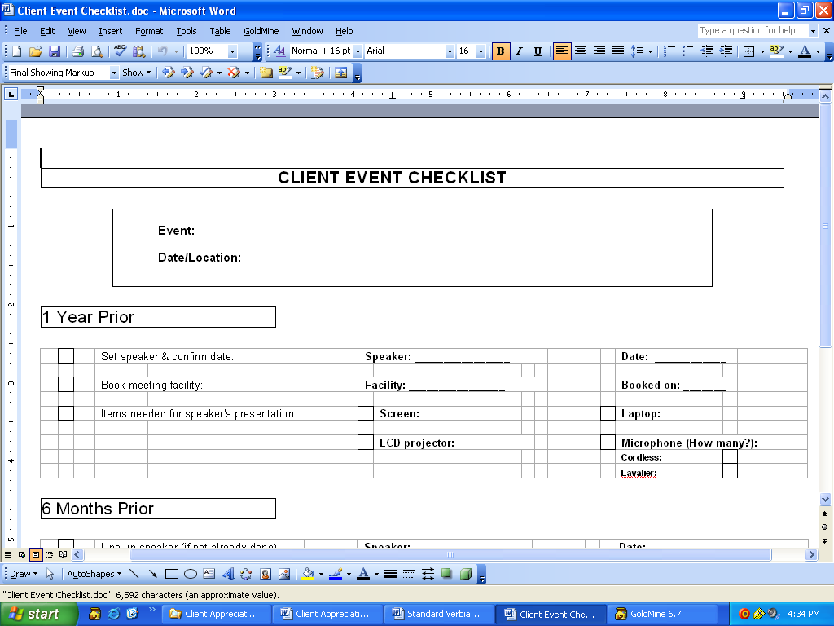

Note: To view the entire letters(s) or form(s), please refer to the Table of Contents in the Forms (FR) section of this Systems Manual.

3) INVITATION CHECKLIST

  - Print the Invitation Checklist.

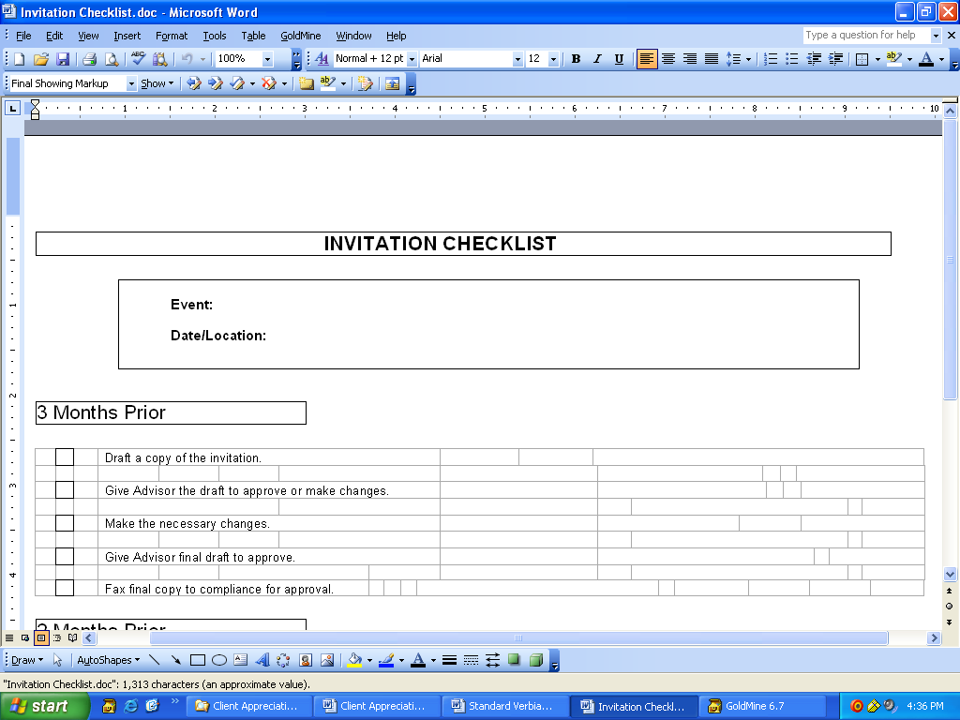

Note: To view the entire letters(s) or form(s), please refer to the Table of Contents in the Forms (FR) section of this Systems Manual.

4) Client eVENT Budget

4.1) Print a Client Event Budget sheet to track the projected and actual costs of events.

Note: To view the entire letters(s) or form(s), please refer to the Table of Contents in the Forms (FR) section of this Systems Manual.

5) fOOD and dRINK SUGGESTIONS

FOOD
Fruit Platter
Cheese and Crackers
Veggies and Dip

Use all three or substitute one filler

FILLERS
Popcorn
Pretzels
Peanuts
Cookies

DRINKS
Coffee, Regular and Decaf
Iced Tea
Water
Tea Bags & Hot Water
Lemonade
Hot Chocolate

6) RESERVATION LINE

6.1) Using a dedicated RSVP line will alleviate call traffic to the staff. Contact your phone company to help set up this feature.

  - Recordings should be changed 3 weeks prior to the event.

  - Script suggestions.

“You have reached the [Insert Company Name] reservations line. We are currently taking reservations for the [Insert Name of Event] workshop being held on [Insert Date] at [Insert Location of Event.]”

“Please leave your name and the name of your guest along with the correct spelling for each as well as your phone number. Should there be any questions regarding your reservation, your phone number shall be considered your confirmation number. For further assistance, please press zero and you will be transferred to the operator.”

Cancellation

“You have reached the [Insert Company Name] reservations line.

Due to inclement weather, the [Insert Name of Event] has been cancelled. We apologize for any inconvenience.”

Postponed

“You have reached the [Insert Company Name] reservations line.

Due to inclement weather, the [Insert Name of Event] has been postoned. Please call [Insert Team Member’s Name] at [Insert Phone Number] for rescheduling information. We apologize for any inconvenience.”

7) ENTERING RSVP INFO IN CONTACT MANAGEMENT SYSTEM

  - When the Client calls to RSVP, enter the information in contact management system.

7.2) When a Client calls to RSVP for a Prospect or a Prospect calls to RSVP, enter the information in contact management system.

  - After the event, make a note of the Clients and Prospects who showed but did not RSVP, RSVP’d but were a no show, and the score on all Event Evalutations.

Note: Carson Wealth always has blank name tags to hand-write for Attendees that show who didn’t RSVP. Who ever is signing in the Attendees must keep a list of the hand-written nametags to allow for proper reporting of number of attendees. Additionally, any nametags that have not been picked up are assumed as no shows and should also be coded in the system for proper reporting.

7.4) The Advisor should follow-up with the Prospect/Referral after the event to offer a Prospect Packet if they didn’t receive one AND begin the Prospect/Referral Initial Contact Checklist as presented in the Prospect/Referral Section of this Systems Manual.

8) EVENT SIGN-IN & EVALUATION

  - Print Sign-in, Evaluation and Upcoming Events form. Print enough evaluations for the number of RSVP’s received plus 5% for walk-ins.

Note: A label with the Prospect’s name and Advisor’s Rep ID# should be printed and affixed to a Sign-in/Evaluation form.

Note: To view the entire letters(s) or form(s), please refer to the Table of Contents in the Forms (FR) section of this Systems Manual.

Note: The Guest Sign-in Sheet should be on the back of the Event Evaluation sheet. You can accomplish either with a printer that has double-sided capabilities or by copying it onto the back of the evaluation from a copy machine.

Note: There are two Event Evaluations on each page. You will want to separate these prior to giving them to your Clients or Prospects.

Note: The Upcoming Events sheet is optional and can be stapled to the Event Evaluation if wanted.

  - Prospects will have an Evaluation attached to their nametag due to a label already being attached to the Guest Sign-in. Clients will have an evaluation and a pencil on their chair.

  - At the end of the event, all evaluations are collected.

  - The following day, the results are tabulated by the Love-Affair Marketing Associate and the results are distributed to the staff.

  - The Guest Sign-in sheets are distributed to the respective Advisor whose Rep ID# is on the pre-affixed label.

9) EVENT NAMETAGS

  - Nametags are prepared for every event we host. View the list of nametags for correct spelling.

  - Print nametags for the event.
- Names appear in ALL CAPITAL letters if a Client.
- Names appear in Proper Case letters if a Prospect or Guest.
- Names appear in Italics if a Vendor, Presenter or Employee.
- Small gray dot in the lower left-hand corner represents the attendee had a birthday in the last 30 days.
- Small gray dot in the lower middle of the nametag represents the attendee’s birthday is the day of the event.
- Small gray dot in the lower right-hand corner represents the attendee has a birthday within the next 30 days.

Sample Nametags from Avery 5395 Nametags Report

9.3) Client event nametag organization at the event.

9.3.1) After printing off nametags, separate alphabetically. Paperclip couples and families together.

9.3.2) Affix a label with the Prospect’s Sign-in Sheet/Event Evaluation and paperclip to the Prospects nametag. (Instructions for Sign-in Sheet and Evaluation Forms are located in the Event Sign-in and Evaluation system below in Section 13.)

9.3.3) Once all nametags have been run, organize them evenly in 3 black expandable files.

9.3.4) Attendees will line up in the line in which the first letter of their first name appears. Signs will be attached to the front of the nametag table.

9.3.5) This will keep the nametag table neat and keep it from getting congested.

9.4) Do not throw away unused nametags as they will be used to determine who were no shows of those who RSVP’d.

10) PROSPECTS ATTENDING EVENT

10.1) The morning prior to an event, the Event Coordinator will make a copy of attendance sheet and provide a copy to each Advisor.

10.2) The Advisors will be responsible for calling the Prospects at least one day prior to the event, introducing themselves, and letting the Prospect know that they are looking forward to meeting them.

10.3) At the event, the Prospect is asked to fill out the Sign-in/Evaluation Sheet at the time of arriving at the event.

10.4) The Advisor will greet the assigned Prospects and socialize with them at the event. One of the goals for each Advisor is to have the Prospects receive a Prospect Packet.

10.5) Prospect Packets will be at the sign in table at the event for anyone interested or they can be mailed to them later.

  - If a Prospect does not show up to the event, it is the Advisor’s responsibility to call them the next day. They are to find out if they would like a Prospect Packet sent to them and mention the next event. If they would like a packet to be sent to them, the Advisor needs to obtain the mailing information and a team member will enter the data in contact management system and then will mail the packet out as per the Prospect/Referral Section in this Systems Manual.

They should also ask them if they have an e-mail address and if so, would they like to have our weekly market commentary.

10.7) The Advisor should call all Prospects that attended 2 days after the event and schedule an appointment. The Advisor should make sure they received a packet and are planning on completing the needed information. If they did not receive a packet, the Advisor should confirm their mailing address and request that a team member enter the data in contact management system and mail the packet out.

Note: Once the Prospect Packet is sent, the Prospect/Referral Checklist should be printed and followed. See the Prospect/Referral Section in this Systems Manual.

11) VISUALIZE THE EVENT

11.1) Before each event, go through the ENTIRE evening, from the moment the guest walks through the door to the moment they leave to make sure you have covered everything needed for the evening.

11.2) Sample items to think about:

11.2.1) Is there a sign with the company name and event name on it? Has the facility updated it? Have you double checked it to make sure it is spelled correctly, etc.?

11.2.2) Is there a reception before the event and will attendees need to be moved to another location for the presentation? How will you signal them to move? Ring a bell, play a chime, make an announcement over a microphone???

11.2.3) Do you have a bar or a buffet open during the reception? What time should those close down? Have you informed the facility as to this time and any other specific instructions on how to handle this?

11.2.4) Is this a charity event? Do you have the names of the charities listed on a sign that will be visible to the guests?

11.3) Areas to think about:

- Check-in table
- Catering area
- Bar Area
- Seating for presentation and/or dining
- Presentation areas – screens, mics, laptops, etc.
- Coat Check
- Parking Lot
- Entrance to the building
- Hallways

12) COMPLIANCE REQUIREMENTS FOR EVENTS

12.1) List of people invited.

12.2) List of people attended.

12.3) Sample of handouts (already compliance approved.)

12.4) Copy of invitation (already compliance approved.)

12.5) Copy of presentation/slides (already compliance approved.)

12.6) Copy of radio advertisement and dates it ran (already compliance approved.)

12.7) Copy of printed advertisement with name of publication and dates it ran (already compliance approved.)

12.8) Copy of e-mail addresses invitation was sent to.

12.9) Copy of e-mail itself (already compliance approved.)

13) EVENT AGENDA

  - Introduction – 5 minutes maximum:

- Introduce self.
- Thank people for attending.
- Introduce team.
- Introduce speaker.
- Announce that there will be a question & answer session following the presentation.
  - Closing:

- Thank speaker for presentation.
- Remind attendees to complete evaluations.
- Mention next 1-2 events.
- Hold drawing if applicable.
- Offer information to anyone interested in obtaining information about the practice to pick up a packet on their way out.

MISC. EVENTS CHECKLIST

This system will be used to plan and host Office Wine Event.

The following checklist and system is compiled assuming all practices are using some type of contact management software. For optimal effectiveness, we recommend you customize each checklist and system to reflect the actual steps that apply to your software/practice.

Office Wine Event
1) _____ Invitations. ____ N/A
(Person Responsible)

2) _____ Place cards. ____ N/A
(Person Responsible)

3) _____ Wine menu. ____ N/A
(Person Responsible)

4) _____ Wine for the event. ____ N/A
(Person Responsible)

5) _____ Food for the event. ____ N/A
(Person Responsible)

6) _____ Table set-up. ____ N/A
(Person Responsible)

7) _____ Dinner bill. ____ N/A
(Person Responsible)

8) _____ Prospect Packet. ____ N/A
(Person Responsible)

9) _____ Event Coordinator’s role during event. ____ N/A
(Person Responsible)
Dinner and Presentation Events
10) _____ Dinner. ____ N/A
(Person Responsible)

11) _____ Presentation ____ N/A
(Person Responsible)
Annual Holiday Brunch Events
12) _____ Facility arrangements/set-up. ____ N/A
(Person Responsible)

13) _____ Entertainment ____ N/A
(Person Responsible)

14) _____ Table set-up/centerpieces. ____ N/A
(Person Responsible)
Friday Afternoon Club Events
15) _____ Staff and/or Clients. ____ N/A
(Person Responsible)

16) _____ Food and beverages. ____ N/A
(Person Responsible)

17) _____ Conference room set-up. ____ N/A

(Person Responsible)

Office Wine Event

1) INVITATIONS

1.1) Invitations and reply cards printed at local print company.

1.2) Invitations will have the event information on it (see sample.) The envelope will have our return address printed on it as well.

1.3) Business Reply artwork was printed on the outside of the Reply card envelope. (You will need to contact your local postal designer to design the artwork to fit the reply envelope) This can NOT be printed in-house. Below is a link where you can locate the “Mailpiece Design Analyst” for your area.
http://pe.usps.gov/mpdesign/mpdfr_mda_lookup.htm
Or you can start from this address:
http://www.usps.com/businessmail101/ and look under “Mail Characteristics”, then under the “TIP”section there is a “mailpiece design analyst” link can be clicked on.

**If you still have a problem finding your local MDA, call your local post office.

1.4) Once these invitations/reply cards/envelopes are printed, they are then
sent on to Digital Print & Mail Solutions. They print the addresses on the outside of the envelope and also apply a live stamp to each piece. If there are more than 500 you can send them out bulk using a live stamp, but anything less you will have to send with a first class stamp on it.

2) PLACE CARDS

2.1) The place cards are ivory and the guests’ name is printed on both sides of the card. Each wine is also printed on a place card to set in front of each glass. This allows presenter and guests to see names at the same time.

2.2) The brand we have used in the past, and the brand that the template is set up for: Masterpiece Studios – www.masterpiecestudios.com, purchased at Office Depot.

3) WINE MENU

3.1) Paper for the menus was purchased at myexpressions.com and are printed in-house.http://www.myexpression.com/prodDetail.cfm?ProductID=2430&ProdCategoryID=14&ProdSubCatID=12

3.2) See attached sample of wine menu below (front and back.)

4) WINE FOR THE EVENT

4.1) We go through a local wine supplier for the wine and wine specialist who presents the wine throughout the evening.

  - Wine for this event were First Growth Bordeaux wines:

- 1998 Chateau Mouton-Rothschild
- 1998 Chateau Haut-Brion
- 1998 Chateau Latour
- 1998 Chateau Margaux
- 1994 Cateau d’Yquem

5) FOOD FOR THE EVENT

5.1) You will also need to coordinate the food with the Wine Specialist presenting the wine tasting. They should choose the food (cheese and pate’) based on the wine being served. Food descriptions (cheese and pate’ and corresponding colors) are printed on the back of the menu along with where the wines can be purchased (see attached wine menu).

5.2) Heavy hors’devoures are served since the event is held at 7:00 pm.

Cheese
- L’Edel De Cleron (France)
- Champignon Double Cream (Germany)
- Sant Andre Triple Cream (France)
- Manchego (Spain)
- Red Leichester Aged Cheddar (England)
- Aged Gouda (Holland)
- Jarlsberg (Norway)
- Chevre (France)
- Paglietin (Italy)
- Martin Collet Brie (France)

Pate’
- Mousse of Chicken Foie Gras with Hazelnuts
- Pate’ of Pork and Champagne with Black Peppercorns
- Mousse of Duck Foie Gras with Truffles and Port Wine
- Pate’ of Pork Foie Gras with Truffles and Cognac

Miscellaneous
- Wildcat Sausage
- Dharma Sourdough French Baguette
- Red, Green and Black Seedless Grapes

5.3) All food was pre-plated and pre-set prior to the guests arriving. The cheese and pate’ had to be cut into equal portions based on the number of guests attending. The bread was sliced and placed in two bread baskets which were set on the table for guests to pass. Fill water glasses with water and have a couple of pitchers of water available. During the wine tasting, replenish guests’ water as needed.

5.4) Each piece of cheese and pate’ had to be “marked” in order to distinguish which was which. We purchased wooden toothpicks and ten different colors of glass beads for each of the cheeses. We glued two glass beads onto one end of the toothpick. You will need to make enough colored toothpicks for each guest (ex. 10 different cheeses for 10 guests = 100 toothpicks/10 toothpicks of each color). Do the same for each pate’. Colors are also printed next to the food descriptions on back of the wine menu.

  - The “Table Set-Up” (see sample) is such that five wine glasses are set in front of each guest above the place mat. The hors’devoures plate, dessert plate, napkin and menu are set on top of the placemat. On top of the napkin, place a cocktail knife and fork.

- The following items were purchased at Cost Plus World Market (www.costplus.com) for the table set up:
  - Eclis square dinner plate
  - Wicker French bread baskets
  - Cocktail knives and forks

- Placemats were purchased at Bed Bath and Beyond
  - Ambrosia Black Placemat
  - http://www.bedbathandbeyond.com/product.asp?order_num=-1&SKU=102021&RN=64

- Linen napkins were purchased at Linens and Things
  - Foreston Trends Soho Table Napkins in Claret
  - http://www.lnt.com/product/index.jsp?productId=1352423&cp=1332244&view=all&parentPage=family

5.6) Napkins were folded in a flat/pocket fold, adjust the fold to fit the wine menu. http://interiordec.about.com/cs/napkinfolding/l/blnapkfold007.htm

5.7) Wine presenter and Advisor are always seated at the head of the table.

5.8) A presentation was given by Advisor after everyone was seated. The presentation is usually a ‘welcome’ and an overview of our company and our services.

6) TABLE SET-UP

Napkin is folded and placed to the left of each plate.
The Wine/Food menu is placed in the pocket of the napkin.
The wine place cards were placed directly in front of each wine glass
and the name place card was placed at the top of the middle wine glass.
To the left of the plate is the dessert plate and to the right of the plate is the water glass.

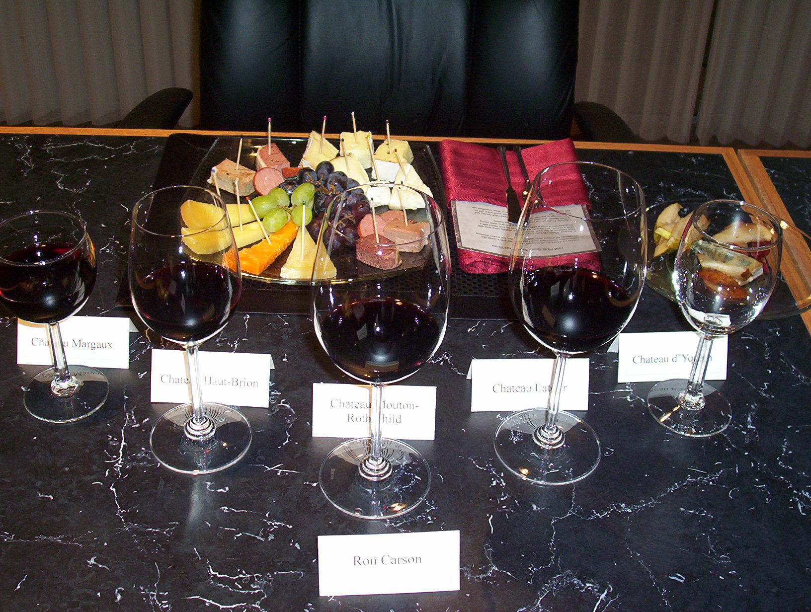

7) DINNER BILL

7.1) The Wine Specialist/Caterer will bill the practice for the wine and food.

8) PROSPECT PACKET

8.1) These are given out to the guests as they leave. They are too bulky to have on the table with the place settings.

8.2) 1 Prospect Packet is given to each couple or each individual if attending alone.

8.3) Make sure to inform the appropriate team member in order to have these prepared ahead of time.

9) EVENT COORDINATOR’S ROLE DURING EVENT

9.1) You need to start setting up the room as soon as you can get into the room you are using. Set the placemats first, followed by the wine glasses, water glass and place cards. Then the napkins with menus and the cocktail utensils. Set the plated food out last, right before your guests show up.

9.2) Food preparation will take quite a while if the cheese, pate’ and bread are not pre-sliced. Ask the Wine Specialist/Caterer if it would be possible to have all the food pre-sliced and on trays. This way you will only need to pre-plate the food. If the food is able to be pre-sliced, you will need to let the Wine Specialist/Caterer know the number of guests attending in order to have the food divided equally among the guests. If you will be slicing the food, be sure to have quality cheese and bread knives on hand. Presentation is key!

  - Take guests coats (if weather is applicable). Greet the guests and show them to the room.

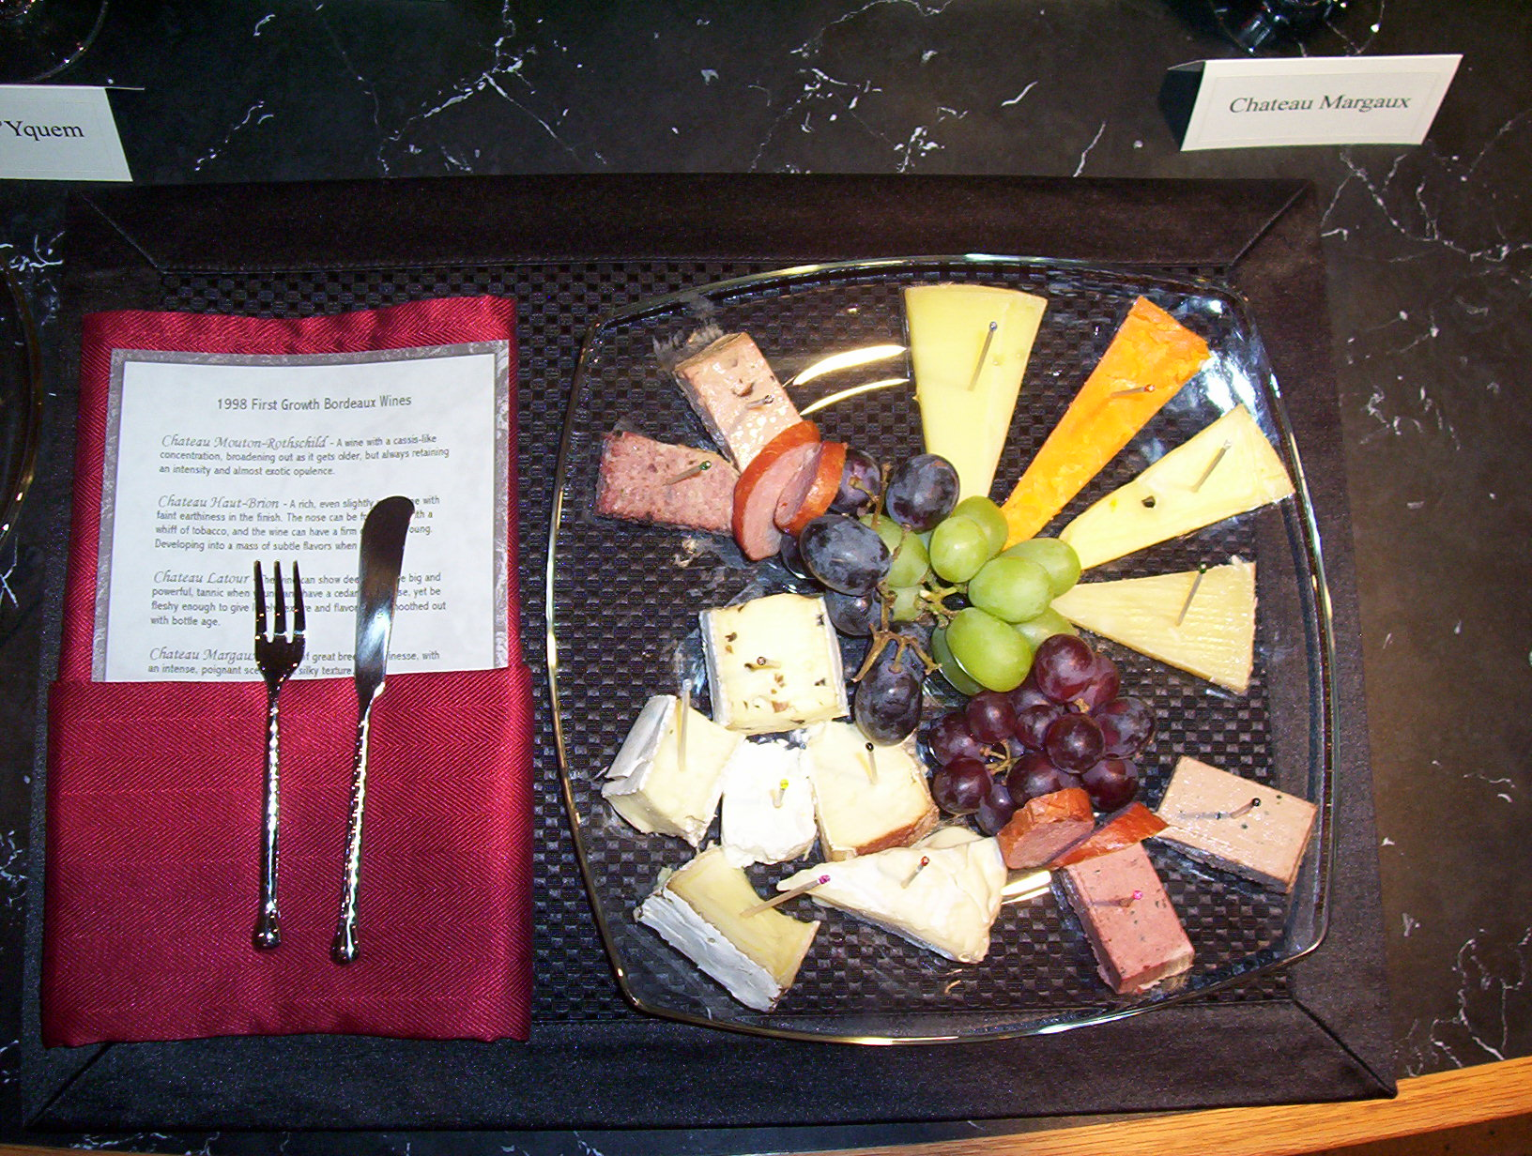
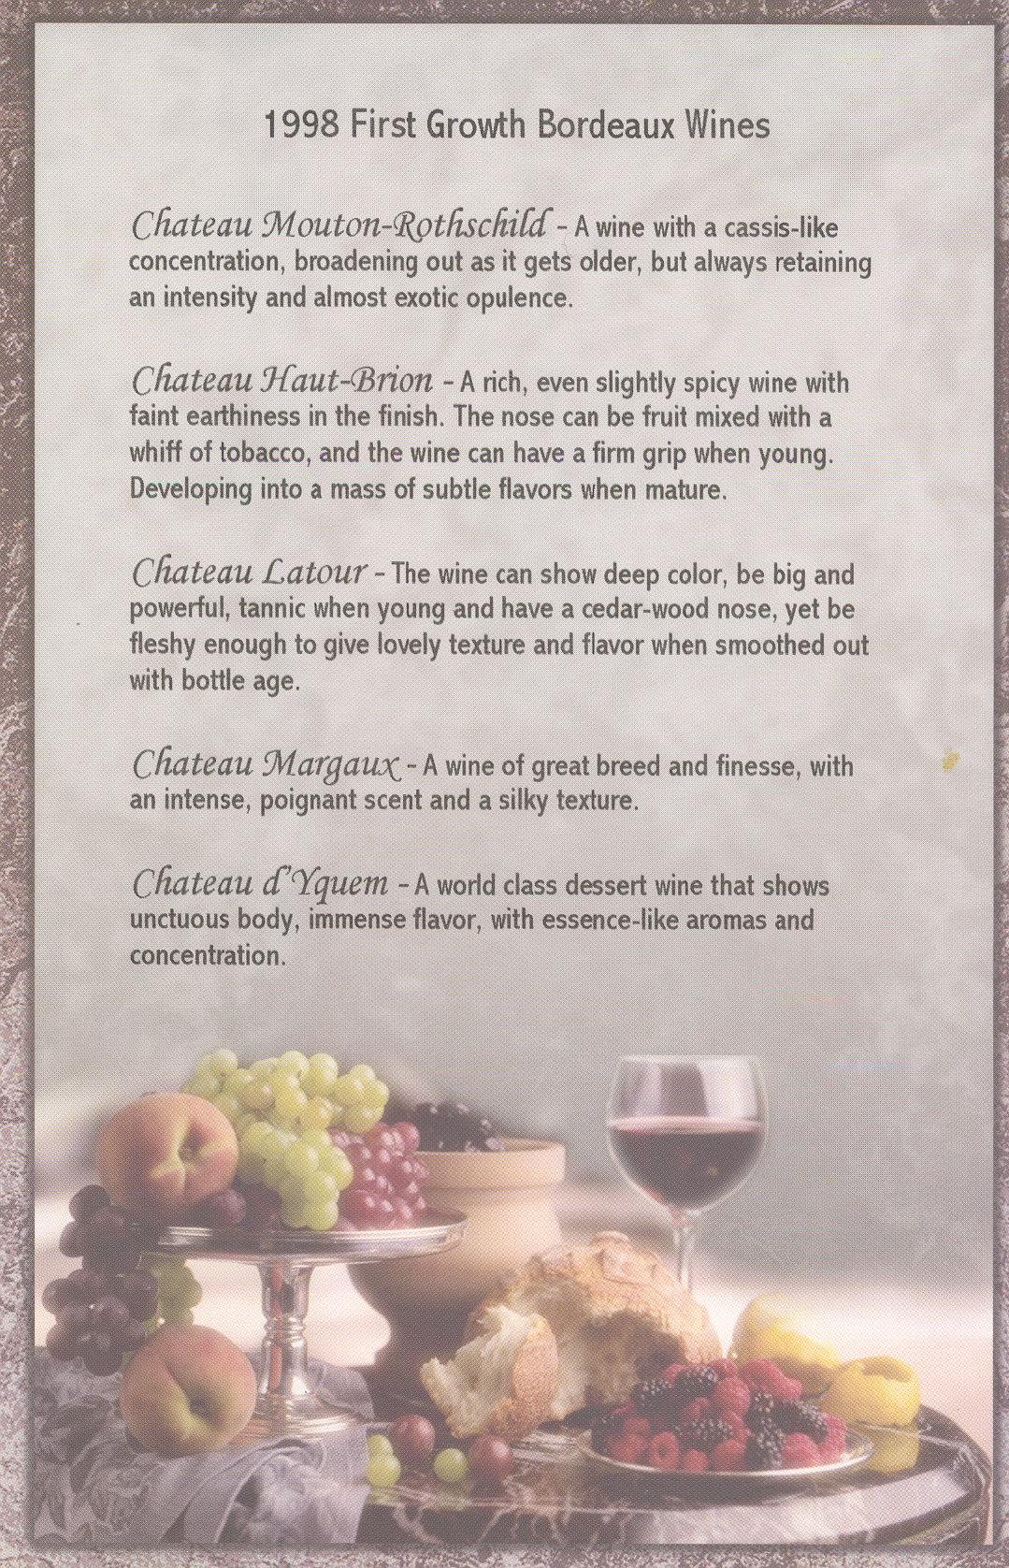

(Front of Menu)

Cheese

BLACK – L’Edel De Cleron (France)

PURPLE – Champignon Double Cream (Germany)

PINK – Saint Andre Triple Cream ( France)

GREEN – Manchego (Spain)

ORANGE – Red Leichester Aged Cheddar (England)

BLUE – Aged Gouda (Holland)

CLEAR – Jarlsberg (Norway)

YELLOW – Chevre (France)

RED – Paglietin (Italy)

LIGHT BLUE – Martin-Collet Brie (France)

Pate’ by Marcell and Henri

PURPLE – Mousse of chicken foie gras with hazelnuts

GREEN – Pate of pork and champagne with black peppercorns

BLACK – Mousse of duck foie gras with truffles and port wine

PINK – Pate of pork foie gras with truffles and cognac

Wohlner’s Homemade Wildcat Sausage
Dharma Sourdough French Baguette

(Back of Menu)

Dinner and Presentation Events

10) Dinner

10.1) How many courses is the dinner?

10.2) Will the guests have their choice of food selection?

Salad? _______________
Entrée? ______________
Dessert? ______________

  - If they do have their choice of food selection, when will this order be taken?

Evening of the event?
On a reply card submitted prior to the event?

  - Will the dinner be served in the same room as the presentation?

  - How will the tables be set?

Square?
Round?
How many at each table?
Will there be a staff member sat at each table?

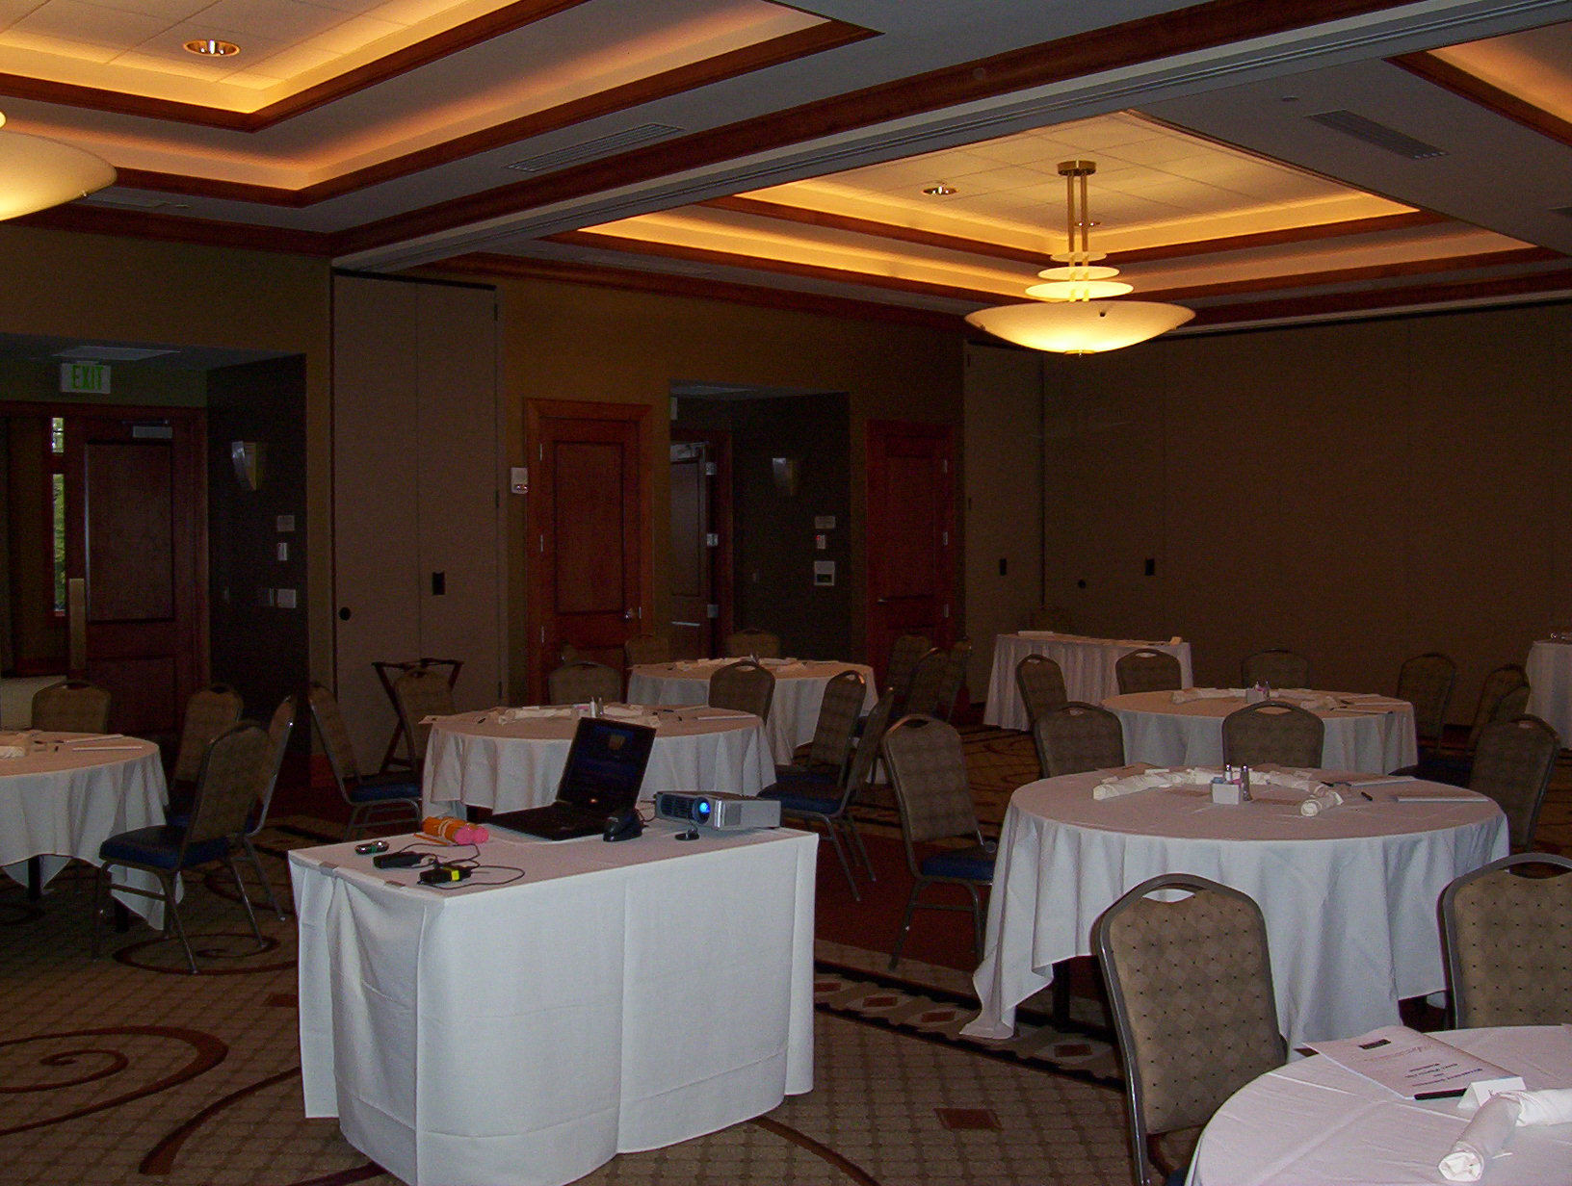

  - Table Settings?

Make sure the place settings (silverware, napkins, & glasses) are placed on the tables prior to the guests arriving. This will make the dinner go much smoother when the staff does not have to enter the room to do that first.

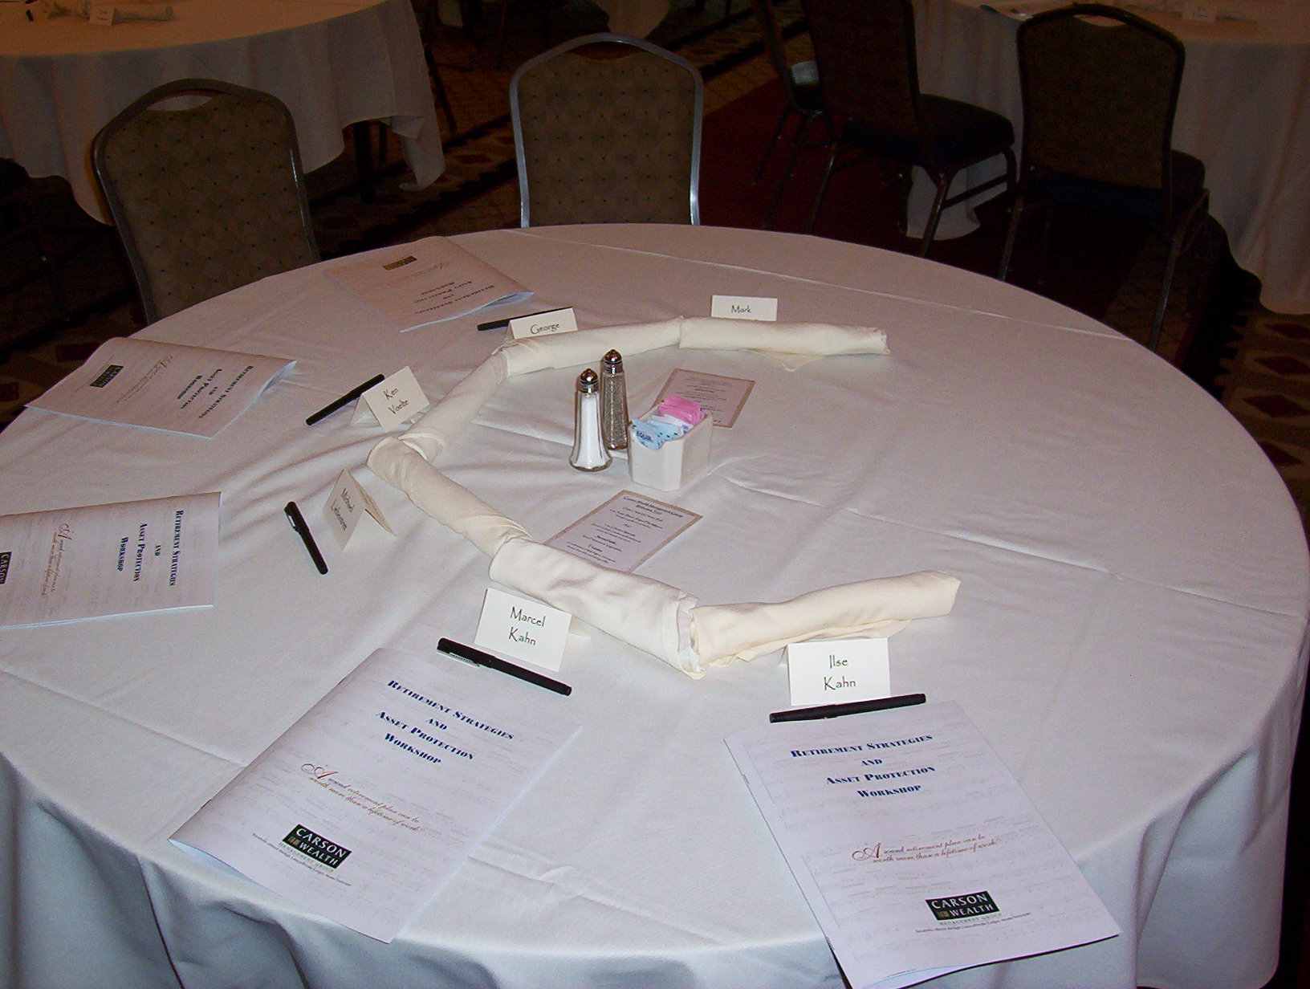

  - Add any additional items to the table prior to the guests arriving, such as placecards, pens, workbooks, menus, etc.

  - Where will the remaining beverages be served? (Ex. Tea, coffee, etc.)

On a serving station in the room for them to serve themselves?
Served by facility’s catering staff throughout the evening?

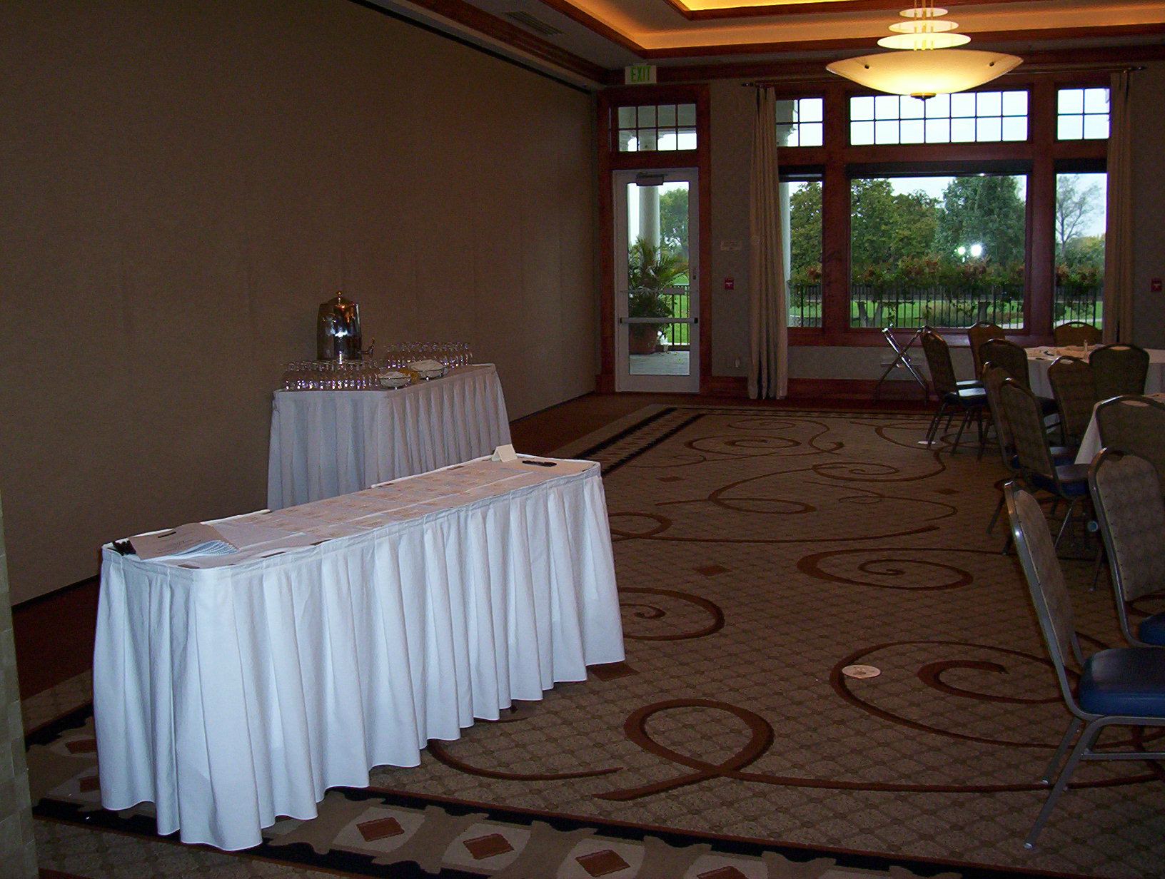

  - When will the 1st course be served?

After presentation?
Prior to the presentation?

Make sure to tell the wait staff so they will be prepared to serve on time. If there is a presentation prior to the dinner most likely the guests will be ready to eat ASAP.

  - If this is an event which will include wine with each course, will there be a specialist there to announce each wine?

Contacted? ________________
Confirmed? _______________

  - Will there be entertainment during dinner?

Live?
Performer: ____________________
Contacted? _________________
Confirmed? _________________

Piped in music through the PA system?

If this is the case, will the facility take care of running this or do they need to show you how to prior to the guests arriving.

If you need to control it, make sure to know how to turn it on and off and to adjust the volume.

  - You will need a registration table. Where will this be set up? Inside or outside of the room?

11) presentation

  - If you are using a PowerPoint Presentation make sure that the laptop is placed on table or a podium where the presenter will be able to see it while they are presenting. Basically, make sure it is placed so that they do not have to look at the screen to know what slide is up next.

  - If you are using a PowerPoint Presentation then you will need an LCD projector. Ask the facility if this is included in the price of the room. If you borrow one, you will need to set it up yourself. If you are not familiar with this set up, make sure to set it up once at the office the day before in order to make sure you have everything you need, then arrive extra early to the facility in order to avoid any problems with set up. A screen is also necessary.

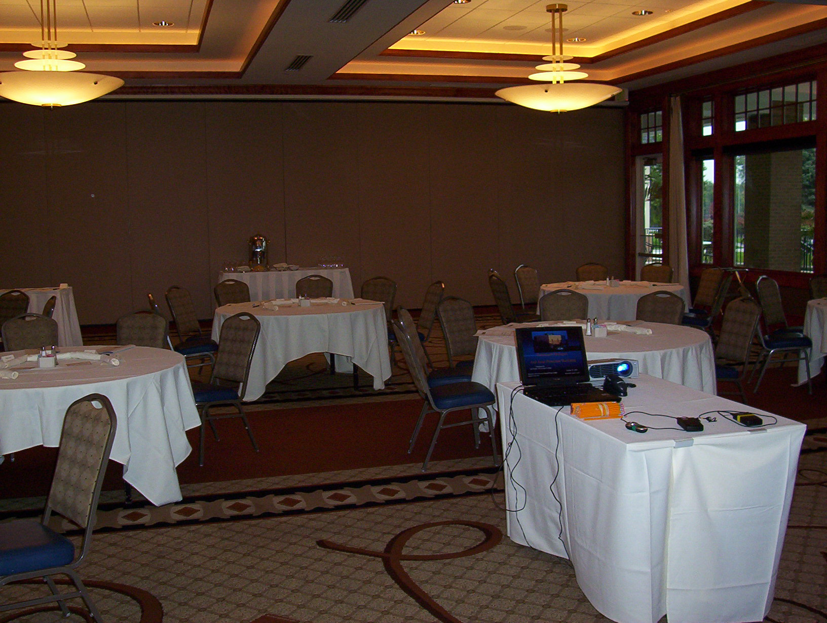

  - Make sure to have a glass of water for the presenter either on the podium or on the table.

  - Each presenter should have 1 lapel microphone and always have at least 1 stationary microphone available if someone is to introduce, make closing comments, etc.

  - You should also make sure to have a presentation mouse or a cordless mouse for the presenter to advance the slides.

  - If there is a video or any audio that needs to run through the sound system, make sure the facility is aware of this so they can get the proper equipment needed to make this work.

  - Always run through the presentation on the laptop the day before to make sure it is running smoothly.
Annual Holiday Brunch Events

12) facility arrangements/set-up

  - Contact facility.

Contact Name: _________________________________
Phone Number: _________________________________
Email Address: _________________________________

  - Coat check Yes No

  - Where will the sign-in table be located? ________________

How many tables will be needed: _____________

  - Each year there MUST be a speaker. Speaker arrangements (does the facility have these items):

Podium __________
AV Items __________
Microphones __________

  - Buffet Set-Up & Food:

How many lines will there be? ____________

Will there be any sort of serving station for ham, or any other specialty food? ____________________________________________________

Food/Beverages that will be served:
____________________________________________________
____________________________________________________
____________________________________________________
____________________________________________________

  - Make sure to stress how important it is for them to have enough staff to meet our needs throughout the morning AND how early they need to be ready to go.

  - When will the facility need to know a final count for the food? ____________

  - How does the facility charge? Per Person or Per Plate

13) entertainment

  - Contact harp player or other small musical group.
Who: ________________________________
Phone:________________________________
Other Info: ____________________________

  - Verify if need a microphone: Yes No
If Yes, request this from the facility or rent: ________________

  - Verify the amount that will be due that day: ___________________

14) table set-up/centerpieces

  - Discuss with facility contact what the set-up of the room will be:
___________________________________________________

How many will the room seat at one time: _________________

  - Centerpieces:

Provided by the facility/cost:

# needed: __________________
Cost per piece: __________________

Ordered from an outside company/cost:

Company Name: _________________
Phone Number: _________________
Date ordered: _________________
# ordered: _________________
Cost per piece: _________________
Being delivered? Yes or No
Time of delivery: ___________

Friday Afternoon Club Events

15) Staff and/or Clients

15.1) Is this event for staff or staff/Clients? ______________

15.2) If the event will be for Clients as well, ask Advisor how he would like to invite them? In the past we have sent simple invitations printed on wine themed paper.

15.3) How many people will be attending? ______________

16) food & beverages

16.1) Food:__________________________________________________________

16.2) Beverages: _____________________________________________________

Items to order:
Cheese Tray w/ assorted crackers
Jumbo Shrimp
Miller Lite and Bud Light/Coors Light
Corona & 1 lime
Wine

16.3) Fax in the order the day before it is needed. Have it delivered 30 minutes before the event is planned to start.

16.4) ALWAYS order enough ice! Usually 4 bags of ice are enough.

17) conference room set-up

17.1) Put all of the beer in the tubs along with ice.

17.2) Set out all food along with plates, napkins, glasses, and any silverware needed. This should also include any serving utensils needed for the food.

17.3) If wine is served, make sure to put out enough wine glasses. You will also need a corkscrew.

17.4) Also, make sure to have soft music playing in the background. You can either play the radio or a CD.

