STRATEGY 9: FORM PROFITABLE STRATEGIC PARTNERSHIPS

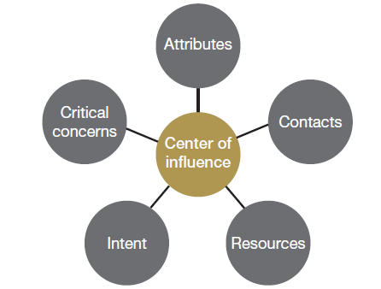
COI Assessment Interview Guide

Attributes
- Tell me about your practice.
- What services do you specialize in?
- What is the most difficult thing about making your practice much more successful?
- Where do your practice see in a few years?

Contacts
- How many clients are you currently working with who have businesses valued at $10 million or more?
- What are you doing for these clients?
- Is there a particular type of client, such as business owners, corporate executives or celebrities, that make up most of your wealthy clientele?
- How do you generally meet wealthy prospects?
- Are you working with any other professionals who send you a steady stream of new wealthy clients?

Resources
- How would you distribute the thought leadership content I’d provide to you?
- How much money do you have for workshops and other types of educational events?
- If we wanted to run educational lunches for clients and prospects, what kinds of rooms are available at your firm?
- What kinds of material are you sending out today?
- Do you send out material consistently or once in a while?

Intent
- Do you want to make a lot more money?
- How would becoming much wealthier impact your family?
- How useful would it be for you to be recognized as one of the foremost authorities in your field?
- Where would you like your practice to be five years from now?
- What are the biggest obstacles to making your practice more successful?
- Besides greater business success and more money, what is really important to you?

Critical concerns
- Is there anything that will stop or slow us down from working together?

