Mutual Commitment Meeting Scripts

Step 1. Greet the prospective client by name. Reinforce some aspect of his or her high-net-worth personality.
Use the same approach and greeting as in the two previous meetings. When you greet the prospective client, again be sure to reinforce some aspect of his or her high-net-worth personality and to communicate that you are excited about the progress you are making together.

Step 2. Set the stage for the meeting and review the agenda.
As with previous meetings, set the stage by stating the ideal outcome for the meeting and asking for affirmation from the prospective client:

“Joe, our ideal outcome today would be for us to both make the mutual commitment to working together, and then to start that process by executing the needed paperwork. How does that sound to you?”

Assuming a positive response, briefly walk through the agenda.

Step 3. Collect and address all questions.
Next ask whether there are any questions about the investment plan.

“Joe, I continue to be excited about our plan. Remember, we have two jobs here: The first is to help you make informed decisions about your money so that you can achieve all that’s important to you. The second is to provide you with peace of mind.

“With this plan, I feel strongly that we are well on our way to making informed decisions, but I wanted to check in with you to make sure that you’re comfortable with where we are. With that in mind, what concerns, if any, do you have today about implementing our plan?”

If the prospective client does have questions, write down all of them before you respond to any of them, as in the previous meeting. Keep asking, “Are there any other concerns?” until you have heard them all.

Do this because you want to address all concerns but you do not want to set yourself up for a debate. When people are investing their life savings, they often feel that they should have questions. By uncovering all questions before answering any, you can be very thoughtful in addressing the big picture first and then any details. It will also help you discern whether there is a pattern of questions that might be disguising a bigger underlying concern.

As you respond to questions, use your proof statements as applicable to address those issues. If you need to make any adjustments to the investment plan as a result of the concerns, just mark up the changes on the plan.

Step 4. Execute the documents.
Once you have addressed all questions, say that you are ready for the prospective client to set the plan in motion by executing the required account documents.

Have all the paperwork prepared in advance, with “sign here” stickers attached in the appropriate places. As the prospective client may often be opening multiple accounts, take time to explain each set of paperwork. At this time you will also collect any checks, as appropriate.

Alternately, if the documents are to be executed electronically, walk the client through that process. Provide a tablet for this, not a laptop, as it will feel more accessible and personable.

If you have a good client service representative, bring him or her in at this point to handle this step. There are two reasons for this. First, this team member is probably much better than you at these administrative tasks and is less likely to overlook a detail. Second, it immediately establishes a relationship between the client and the client service representative, opening the door for future administrative questions to go directly to him or her.

If you have a truly outstanding customer service representative, consider leaving the room while he or she handles the document execution. This will create an even stronger relationship between the client and your team member. Once the documents are executed, return to the room to move on to the next step.

If you are working with the client in a virtual environment via Skype, FaceTime or other video calling program, you can ask the client to execute the documents electronically. The Resources section contains our recommendations for several digital signature programs.

Step 5. Congratulate the client.
Once all the documents have been executed, pause for a moment to congratulate the client. You might say this:

“You should be commended for doing a great job. Congratulations on taking an extremely important step toward securing your financial future and achieving all that is important to you.”

Step 6. Caution about “buyer’s remorse.”
It’s important for your client to understand that he or she will end up with buyer’s remorse if relying on the financial media to reinforce prudent investing decisions.

Encourage the client to ignore the media (or to view it simply as entertainment) and to focus instead on making wise financial decisions and sticking with a long-term plan for maximizing the possibility of achieving all that is important to him or her.

This is very effective in focusing clients on what is truly important:

“I know you’re excited about your new plan. However, do you know what’s going to happen as soon as you walk out the door? You’re going to do what most of us do after we’ve made a major transaction: You’re going to wonder if you’ve done the right thing. You’re going to have “buyer’s remorse.”

“In fact, you’re going to be flooded with all kinds of information from television and the financial magazines that will create some confusion. Let me give you a simple example for something that’s not even close to being as important as what you’re doing with your money—buying a car.

“Who do you think are the biggest readers of car advertisements—people who are looking to buy a car or people who have just bought a car? You might be surprised, but the No. 1 readers of car advertisements are people who’ve just bought cars, primarily because they want to rationalize that they made the right decision.

“So as you go out and are exposed to the financial media—magazines and cable TV shows and so forth—we’re going to encourage you not to pay attention to it.

“Our job is to help you make informed decisions about your money so that you don’t need to pay attention to all that. As a matter of fact, many of our clients cancel their subscriptions to the Money magazines of the world so that they can focus on what’s really important to them, like …” (Depending on the prospect’s high-net-worth personality, reiterate what he or she has shared about what’s important.)

Step 7. Explain the concentrated nature of investment gains.
Help your client to stay the course over the long run by explaining that the uneven nature of investment gains is an unavoidable part of attaining investment goals. Illustrate this by showing the client the chart below. Point out that missing just a few days over the past several decades would have resulted in a drastically lower return than would have been realized by staying invested throughout the period. (This chart is included in the sample IPS.)

Performance of the S&P 500 Index, 1990–2018
Hypothetical Growth of $1,000
Annualized Compound Return
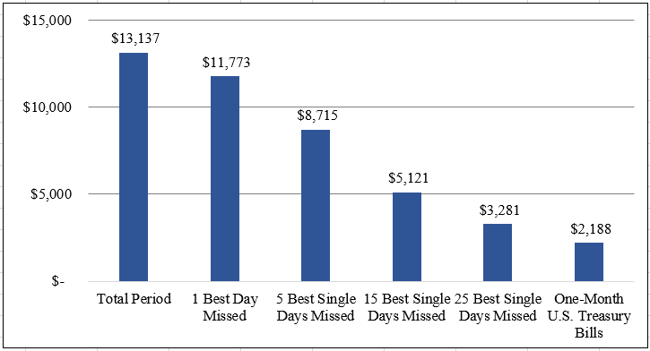

Explain that the uneven nature of investment gains is an unavoidable part of attaining investment goals. It is quite effective to set expectations in this way:

“If, on average, only one month out of each year looks good, how often during our quarterly meetings will it look good? That’s right, only one quarter out of every year will look good.

“That means that in three of our four Regular Progress Meetings each year, you’re going to come in here and question why you’re paying me. I’d like to emphasize now that what you’re paying me for is not just managing your money, but helping you make informed decisions about your money so that you can maximize the probability of achieving what’s most important to you. But to get the higher rates of return, we have to take some risk, and risk means volatility.”

Step 8. Make the second-opinion service offer.
Now that your prospect is a client, you should immediately begin to leverage the relationship by offering your second-opinion service to the people he or she cares about. Since your new client is impressed enough to trust you with his or her financial future, he or she is often eager to have friends or family members have the same experience. You simply have to make the offer.

Beginning with the Mutual Commitment Meeting and continuing for every client meeting after that, make your second-opinion service offer to your clients like this:

“I want to offer you a complimentary service that we call our second-opinion service. It’s for the people you really care about—your friends, family members and colleagues—who may be in a complex situation or who just want to make sure they’re making smart decisions in today’s economy. We help the people taking part in this service to make informed decisions by providing them with a second opinion on their finances.

“When you introduce us to someone, we will take them through the same experience you’ve had with us. We’ll take them through the discovery process to get very clear on where they are now, where they want to go and what the gaps are. Then we’ll evaluate whether their current financial advisors are taking good care of them. If they are, we’ll recommend that they stay with their current advisors. If not, we’ll evaluate whether we would be the right advisors. As you know, we limit our practice to people for whom we can make a major impact. If we’re not the right advisors for them, we promise to point them in the direction of the right solutions.

“Whom do you know who would benefit from this service?”

Step 9. Close the meeting.
Explain that the next meeting is the 45-Day Follow-up Meeting, at which you will help the client to get completely organized with all the new account paperwork that he or she will receive over the next several weeks. Ask the client to save all this paperwork and bring it to the meeting. Agree on a date for the meeting that will be about 45 days, or six weeks, in the future. (Again, you may want to use your graphic overview of the wealth management process to remind the client about where you are in the process.)

“Joe, we need to schedule our next meeting—the 45-Day Follow-up Meeting—so we can get you organized with all your new paperwork. It will take about an hour. How does Thursday, June 26, at 11:00 a.m. look for you?”

At this point, you have done everything to delight the client. Do not thank the client for doing business with you, but rather acknowledge that you are glad that you can play an important role in helping to achieve all that is important to him or her. Simply wrap up with this:

“I’m happy to be able to play such a valuable role in helping you to achieve all that is important to you. I’m looking forward to working together and to seeing you again in six weeks.”

Step 10. Send confirmation of the next meeting.
As you did following the previous meetings, send a letter or email the same day to confirm your next meeting. Also, remind the client to bring the paperwork he or she receives in coming weeks to the meeting, and thank the client for any introductions provided.

